Literature Review

Supervisor | Bernadette Brosnan

Computing in loud computing

Margaret Buckley D00196901

2023

Contents

**1.** **Background & Abstract** 2

**2.** **Aims** 3

**3.** **Development Platforms** 4

**4.** **Backend Technologies** 7

**I.** **Cloud vs no-cloud** 7

**What are the advantages of cloud**? 7

**II.** **Database** 9

**III.** **Real-time Database** 10

**5.** **Selection** 12

**6.** **Justification** 13

**I.** **Justification for Development** 13

**II.** **Justification for selection** 13

**III.** **Justification for the database** 13

**IV.** **Justification for real time database** 13

**7.** **Design** 14

**8.** **Frontend Design** 15

**9.** **Architecture pattern/Design** 16

**1.** **Database Design** 17

**I.** **Authentication** 17

**II.** **Fire store Database** 17

**III.** **Realtime Database** 18

**IV.** **Storage** 18

**2.** **Implementation** 19

**I.** **How you implemented it** 19

**II.** **Environment Setup** 19

**1.** **Install Node.js** 19

**2.** **Install npm (Node Package Manager)** 19

**III.** **Functionality** 21

**I.** **Gherkin** 24

**3.** **Agile Development** 32

**4.** **Conclusion** 33

**5.** **Appendix** 34

**II.** **Survey** 34

**III.** **Plan and Progression** 39

**IV.** **Useful links** 46

6. References 47

## **Background & Abstract**

Sosad Ireland has been working to raise awareness and prevent suicide in Ireland since 2007. They have worked tirelessly in the communities to make those in need feel supported and to let them know they are not alone on their journey. Sosad Ireland offers free support and services to people dealing with suicidal ideation, self-harming, bereavement, depression, stress, and anxiety, or simply needing someone to talk to.

This report discusses a cross-platform application, the application will be developed using Google Maps API and an API for motivational quotes, Firebase, Ionic, and Angular frameworks using visual studio as the code editor. It has various features including motivational quotes, CRUD events, staff rosters, volunteer application forms, and a call-back request, chat service, office details, office location. The application will use firebase as the database.

## **Aims**

This application supports administrators, volunteers, and clients to access and use the Sosad services, which are designed to provide a platform for fostering support. With this application, you can easily apply to become a volunteer, stay updated on upcoming fundraising events, and participate in the chat service with trained staff. The chat service allows you to respond to messages. Additionally, you can view the roster and see who is available on what date. The notice board will keep staff informed about critical updates and announcements. You can also listen to real talk videos. The application also allows you to create, edit, delete, and update events, allowing the user to stay on top of what is happening, whether you are a volunteer, client, or administrator.

* + Apply to be a staff member.
  + Use the chat service.
  + Listen to real talk videos.
  + Create, edit, delete, update and view fundraising event.
  + View roster.
  + Notice board.

## **Development Platforms**

**What is a software application?**

In simple terms, a software application is a computer program designed for mobile devices like smartphones and tablets, as opposed to desktop or laptop PCs. Depending on how they are built, mobile apps can be categorised into four groups, each with its own set of characteristics, advantages, and disadvantages. The following are brief explanations of each category: (Ivy, UN)

**Web-app**

A web application is a software that runs within a web browser, using programming languages like JavaScript, HTML, and CSS. Web apps allow users to upload and download data to and from databases through a web server, which generates the information in a particular format (such as HTML) displayed in the user's browser. (Contributor, 2022)

**Native app**

A native app is a software that is specifically designed for use on either iOS or Android mobile platforms and is written in a particular programming language. "Java is used for native Android apps, while Swift or Objective-C is used for native iOS apps. (UN, vervelogic, 2021).” (unknown, 2022)

**Hybrid**

A hybrid app is designed to work on multiple platforms and is built from a single codebase that combines features of native apps and web apps. Developers can create a single program that can be downloaded from all app stores instead of rewriting the app for each operating system. Hybrid apps use coding languages with integrations and plugins to offer this functionality. (Lannace, 2021)

**Cross-platform**

Cross-platform apps are designed to work across multiple mobile platforms, such as Windows, Blackberry, iOS, and Android. Programmers can create apps that work on various platforms using a single coding system, resulting in faster development, higher quality, and compatibility with different platforms. (Jackowski, 2020)

|  |  |  |  |  |
| --- | --- | --- | --- | --- |
| **Platform tools** | **Tools** | **Advantages** | **Disadvantages** | **Benefits** |
| Web-app | * Angular * Jquery * Bootstrap * react * typescript * angular * postman * Xampp   (UN, software testing help, UN) (devs5003, 2022) | * It is cheaper than others. * it is kept up dated. * it is easy to run the application.   (Itrobes, 2021) | you need to have access to the internet.Website DependencyIt is not as fast as others.It is not as secure as others. (Itrobes, 2021) | * It allows all users to access the same version of the application on different devices. * It does not need to be installed on the device. |
| Native | 1. Object-C (IOS) 2. Java (android) 3. C# (windows phone) 4. Swift (IOS) | 1. Speed 2. You can work offline. 3. It will look good and is user friendly.   (Khan, 2018) | 1. Lengthy downloading process 2. No flexibility 3. Expensive when developing 4. Time-consuming 5. It requires constant upgrades.   (Khan, 2018) | Native platforms deliver the best results.Native platforms are more secure.They enable access to all the device features for the developers.Native applications have Fewer Bugs during Development (Khan, 2018) |
| Hybrid | 1. JavaScript 2. Ionic 3. Typescript 4. Angular | 1. Fewer development times 2. Cheaper 3. Wider audience 4. Much easier to fix bugs and the maintenance of application. 5. Scalability   (Iannce, 2021) | 1. Operating is slower. 2. Longer testing process 3. Playing catch up on platform update. 4. Less complex functionality   (Iannce, 2021) | 1. It can be used on IOS and android. 2. It can work offline.   The development time is much faster compared to native |
| Cross-platform | 1. Ionic 2. Node 3. Native script 4. Reactive Native   (TechMango, 2022) | 1. Sharable code 2. Faster development time 3. Wider audience   (TechMango, 2022) | 1. Poor design 2. Limited functionality 3. Updating delay   (TechMango, 2022) | 1. You will be able to reuse code. 2. Code will be used on multiple platforms. 3. It has high performance. 4. It also will reach out to different user groups.   (TechMango, 2022) |

## **Backend Technologies**

## **Cloud vs no-cloud**

**What is cloud?**

"cloud" refers to various online computer services such as servers, storage, databases, networking, software, and analytics. These services can lead to cost reductions, better infrastructure management, and heightened innovation. By employing only, the required cloud services, operational expenses can be minimised. A key advantage of cloud computing is the convenience of accessing your business or application from any device, anytime, and anywhere, essentially establishing a virtual office. (Microsft, UN)

### **What are the advantages of cloud**?

**Reduced Costs**

Utilising cloud services can lead to cost savings on system management and maintenance. Rather than investing in costly equipment, opting for a cloud service provider can help reduce expenses. (Globaldots, 2018)

**Scalability**

The cloud allows you to adjust your operating system and storage needs based on your current demands. It can also provide flexibility if those needs change during the project development. By utilising a service provider, managing upgrades is transferred, eliminating the need to purchase and install costly upgrades. Using the cloud can also save time, allowing you to focus on your daily tasks. (Globaldots, 2018)

**Collaboration efficiency**

Collaboration efficiency is enhanced through cloud computing, as it facilitates communication and information sharing among group members or staff working on a project together. Access to duplicate files is made possible regardless of location, eliminating the need to be in the office. Careful access management should be implemented to prevent unauthorised alteration of files. (Globaldots, 2018)

**The flexibility of work practices**

The flexibility of work practices is increased with the cloud, as data can be accessed from any location with an internet connection, providing an instant connection to a virtual office. (Globaldots, 2018)

**Access to automation updates**

Access to automation updates is another benefit of cloud computing, as users can receive updates tailored to their specific needs. Continuous updates to the system with the latest technology are provided as part of the service. (Globaldots, 2018)

**Why cloud**

Cloud computing offers access to data from any device, allowing for easy information exchange without costly upgrades or traditional software. "Cloud computing" refers to various technologies with different pricing options ranging from free to paid. Popular cloud computing solutions include PAAS, SAAS, and IAAS, each providing unique benefits such as pay-as-you-go components for application creation, online access to software to avoid maintenance, and the ability to purchase resources on demand rather than expensive hardware respectively. Some of the most popular kinds of cloud computing solutions are listed below:

**PAAS**

In the PAAS model, businesses do not pay for hosted applications but pay for specific components required to develop their applications. The online vendors provide all the necessary components for building the applications, such as the operating system and infrastructure. (Microsft, UN)

**SAAS**

SAAS is an approach to delivering software applications as a service over the Internet, eliminating the need to install and maintain software on local devices. By accessing software through the Internet, users can avoid the challenges of independently maintaining software and hardware. (Microsft, UN)

**IAAS**

"IaaS," or "Infrastructure-as-a-Service," enables organisations to acquire networking and storage resources on-demand, preventing expensive hardware purchases. IaaS offers excellent adaptability to meet business requirements and is more flexible than conventional on-site solutions. It serves as the basis for cloud computing. (Microsft, UN)

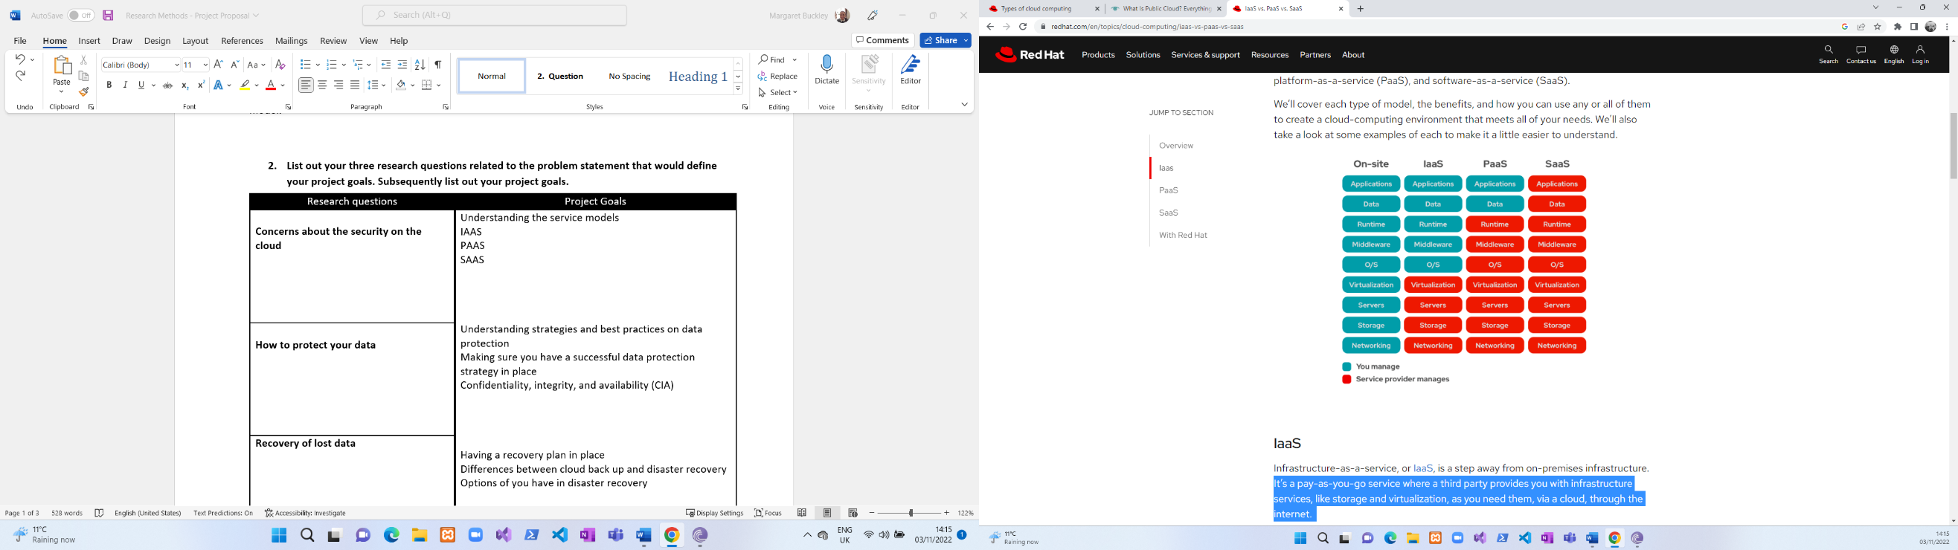

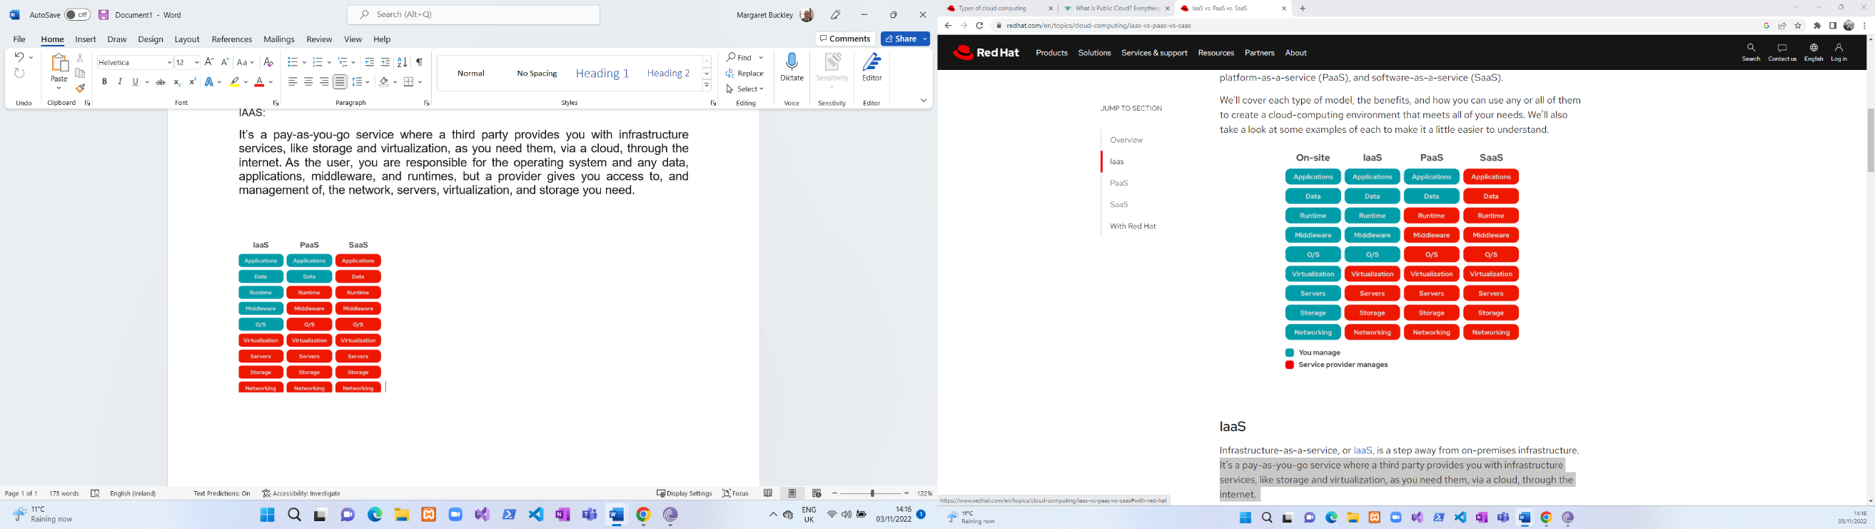

## **Database**

**What is NoSQL?**

Databases are built to handle massively parallel, high-performance data processing and large-scale data storage on various commodity hardware. NoSQL offers a mechanism for you to engage with data that is more closely tied to the application than the conventional relational database strategy does. NoSQL databases often function as clusters of several machines that are distributed systems. Each piece of data is copied among those machines to offer redundancy and high availability. NoSQL databases can hold vast volumes of data in a distributed manner, making them simpler to develop and deploy. (devs5003, 2022)

**What is MySQL?**

SQL, a structured query language, is used by Oracle to develop MySQL. The database, which holds a tonne of data, is made to collect information from websites. MySQL is an open-source database that enables a user or business to edit; it is typically linked to online applications or web services. The data that people enter on a website is stored in MySQL. Users can connect to many websites using the MySQL database. It is an open-source database that enables you to handle your data with this programme in an efficient manner because it is a very powerful, dependable, and robust option. The following is a summary of some advantages of using MySQL. (Un, Oracle, Un)

**Benefits of relational database:**

**Scalability on Demand**

This platform's remarkable scalability can help with the management of embedded applications. This holds even if there is a sizable data warehouse. One of the primary features of the system is its capacity to change on demand.

**High Efficiency**

The unique storage engine used by MySQL makes system administration simpler. The MySQL database server's performance can also be improved. In other words, you can still benefit from this technology even if you have a fast computer system or a website that receives millions of visitors daily.

**Outstanding Transactional Support**

MySQL is at the top of today's fast transactional database solutions. It has several features, including consistent and automated transaction support.

**Relational database**

This database will keep information in several tables with rows and columns. Each database table relates to a particular entity. Examples include clients, goods, orders, etc. It is the primary distinction that distinguishes relational databases as unique. Furthermore, since every table in a database may communicate with any other table, the data flow will be flexible.

**Non-relational**

Unlike relational databases, there are no tables, rows, primary keys, or foreign keys in this form of database, which use these features to store data. Unlike relational databases, this type does not include several connected tables. (Pattinson, Pluralsight, 2022)

**Benefits of non-relational database**

#### **Scalability**

#### Because NoSQL databases are so scalable, they can be scaled to meet the demands of your company. It offers a definite benefit over SQL databases, which can only expand vertically, not horizontally. NoSQL databases can scale horizontally since the data is unstructured. Each component is independent and self-contained since NoSQL databases need less structure than SQL databases. Keeping them all on separate servers eliminates the need to link the items together. (Pattinson, Relational vs. Non-Relational Databases, 2022)

#### **Data types**

With NoSQL databases, you can store and retrieve data with little adherence to the predefined structure. As a result, you will not need to alter the table structures, indexes, or other components for your application to respond to adding new information types. (Pattinson, Relational vs. Non-Relational Databases, 2022)

#### **Data storage**

Many NoSQL databases' capacity to handle enormous datasets can be useful for real-time analytics and other big data applications. To store structured data on the cloud at a scale that allows for simple addition and deletion without any delays or disruptions, for example, the distributed storage system Bigtable was developed. This data type can be instantaneously pulled from Bigtable and provides access control support at all levels, down to specific fields inside your documents, without additional security layers. Since there are no single points of failure, it can store an infinite quantity of data. (Pattinson, Relational vs. Non-Relational Databases, 2022)

#### **Simplicity**

Many NoSQL database management systems require only a small amount of code to get started for developers. One NoSQL database management system that enables programmers to store data in flexible formats and retrieve it using code written in any language they choose is called MongoDB. (Pattinson, Relational vs. Non-Relational Databases, 2022)

#### **Maintenance**

NoSQL databases will not need as much ongoing maintenance as traditional relational databases because they can automatically divide and copy data among nodes. Costly hardware, such as standard SQL-relational databases, new IT infrastructure, vendor support, or pricey software, will require less financial outlay from your business. (Pattinson, Pluralsight, 2022)

**Authentication in Firebase**

in the authentication section in Firebase, you can enable different authentication factors. When users' information is inserted into the database, their password is encrypted and unreadable to hackers. You can also use sign-in methods in Firebase, as seen below in the images. In, Firebase, you have the option for a different authentication login, but in this project, I have selected that the user logins in using their email and password. You can see in the image below the different types of authentications.

## **Real-time Database**

Firebase Real-time Database is a cloud-based NoSQL database that is provided by Google Firebase. It enables users to store and synchronize data in real-time among their clients, making it particularly suitable for applications that require rapid and responsive data updates. The database stores data in the form of JSON objects, and any changes made to the data are automatically synchronized with all connected clients. (Un, firebase, Un)

**Key features of Firebase Real-time Database** (Un, firebase, Un)

* **Real-time data synchronization** Data changes and are instantly shared with all connected clients, facilitating real-time collaboration and updates.
* **Offline support** Firebase Real-time Database SDKs include offline support, allowing the application to operate without an internet connection. When the connection resumes, local data is automatically synchronized with the server.
* **Access control and security** Firebase Real-time Database offers robust security features, such as server-side validation rules and user-based authentication, to safeguard your data and ensure access is limited to authorized users.
* **Scalability** The database is built to scale smoothly with your application, guaranteeing high performance and minimal latency as your user base expands.

**Advantages** (Un, firebase, Un)

* **Real-time data synchronization** Real-time Database delivers real-time data updates, making it perfect for applications needing instant data syncing between users or devices.
* **Offline support** Firebase SDKs include offline support, allowing applications to work even without an internet connection. When the connection resumes, local data is automatically synced with the server.
* **Scalability** Real-time Database is engineered to scale with the application, ensuring high performance and low latency as your user base grows.
* **Cross-platform support** Firebase provides SDKs for various platforms, including Android, iOS, and web applications, simplifying cross-platform app development.
* **Security** Firebase offers robust security features, such as server-side validation rules and user-based authentication, to protect your data and ensure access is limited to authorized users.
* **Ease of use** The Firebase Console and SDKs streamline database management and interaction, allowing you to concentrate on app development.

**Disadvantages** (Un, firebase, Un)

* **Limited query capabilities** Real-time Database has limited query capabilities compared to other databases, making complex queries and data manipulation more challenging.
* **NoSQL structure** Real-time Database uses a JSON-based NoSQL structure, which may not suit applications requiring a traditional relational database structure.
* **Costs** Firebase provides a free tier with limited resources, but scaling your app may result in higher costs as your user base and data usage grow.

**Benefits** (Un, firebase, Un)

* **Rapid development**

Real-time Database streamlines backend development, allowing for faster app creation.

* **Enhanced user experience**

Real-time data updates and offline support provide a more seamless and responsive user experience.

* **Easy integration with other Firebase services**

Firebase Real-time Database integrates seamlessly with other Firebase services like Cloud Fire Store, Firebase Authentication, and Firebase Cloud Messaging, offering a comprehensive suite of tools for app development.

**Reasons to use Real-time Database over Fire store** (Un, firebase, Un)

* **Real-time data synchronization**

Although Real-time Database and Fire store offer real-time data updates, Real-time Database is specifically designed for real-time applications with highly responsive data syncing requirements. Therefore, a real-time Database may be better if real-time data updates are crucial for your app.

* **Presence and connection state**

Real-time Database can monitor the user's connection state and includes built-in support for presence detection (e.g., displaying when a user is online or offline). However, the fire store lacks native support for presence and demands.

## **Selection**

* The cross-platform application was created to enable users to access it on multiple platforms, including iOS and Android. By being accessible on both operating systems, the app has a more extensive user base compared to native apps. It also provides more convenience and dynamism than native apps. Through research, it was discovered that most cross-platform apps utilize cloud technologies and can integrate with various frameworks with ready-to-use plugins. This integration ensures that the app looks and feels the same on iOS and Android. The availability of the app on both devices increases the possibility of more people using it.
* **Security** When a user registers to the system, I will enable authentication in Firebase so that the password gets encrypted automatically so it is unreadable.
* **API** An API will be used for google maps so you can find the location of all our offices across Ireland and for the motivational quotes
* **Cloud** I will be using the cloud for storage in Firebase to upload images for events and new videos.
* **The database** I will be using a non-relational database, and I will be storing the data in Firebase.
* **Ionic** this will be used for the code to make the application work.
* **Angular** will be used to make the application user friendly.

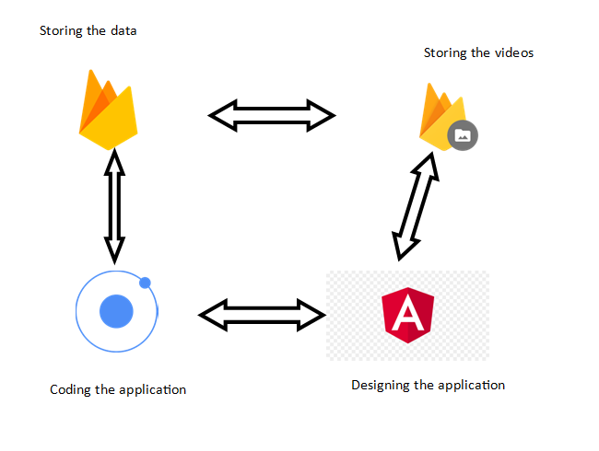

## **Justification**

## **Justification for Development**

By making a cross-platform application, I can reach a larger audience as the app can be used on multiple operating systems such as Windows, iOS, and Android. This can be especially important for businesses that want to reach as many potential customers as possible. In addition, cross-platform development can save time and resources as the same code can be used across multiple platforms, reducing the time spent rewriting the code for the different devices and allowing for quicker updates and bug fixes. Cross-platform apps can offer a consistent user experience across different devices and platforms, enhancing the user experience and increasing engagement with the app. Using a cross-platform software application can provide several benefits, including increased reach, cost savings, and a consistent user experience, making it a valuable option for me as I will be able to carry out a better survey as I will have more participants.

## **Justification for selection**

choosing a cross-platform approach for developing this mobile application will provide a broader target audience, is cost-effective, faster to develop, easier to maintain, and can offer a high-quality user experience. The advantages mentioned above will make cross-platform development an excellent choice keeping costs and development time to a minimum.

## **Justification for the database**

I had initially decided to go with a relational database because I was familiar with it and had used it before. However, I decided against it as I wanted to learn something new. Furthermore, what I wanted to achieve could be a relationship between the different tables. Image 1 is an example of what my MySQL database would have looked like if I had decided to go with that.

Image 1

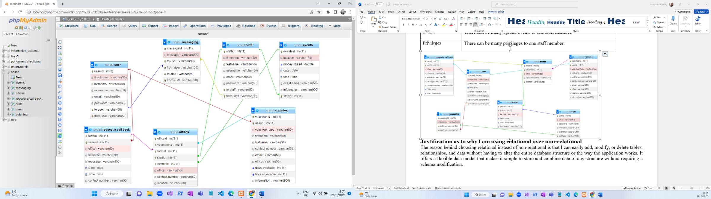

## **Justification for real time database**

Real-time Database is a cloud-hosted database which provides scalability, flexibility, and real-time synchronization capability, which makes it a perfect choice for the chat aspect of the application.

## **Design**

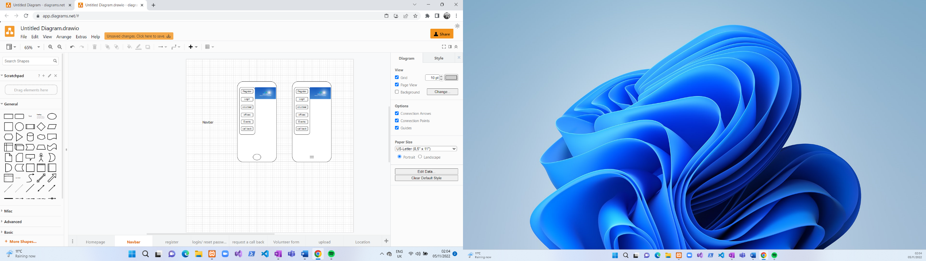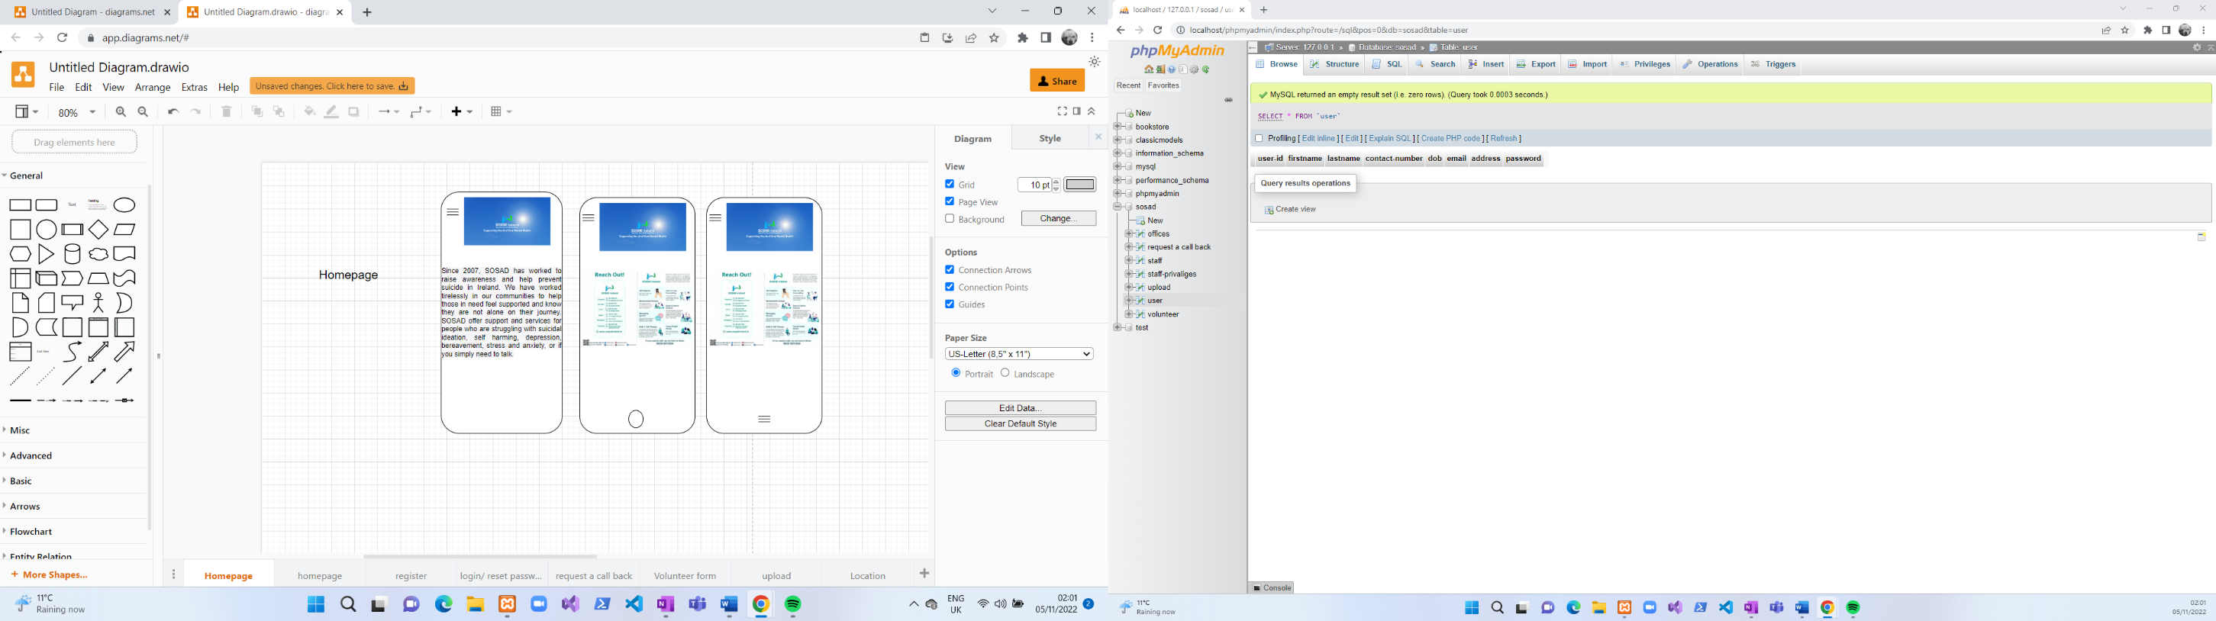

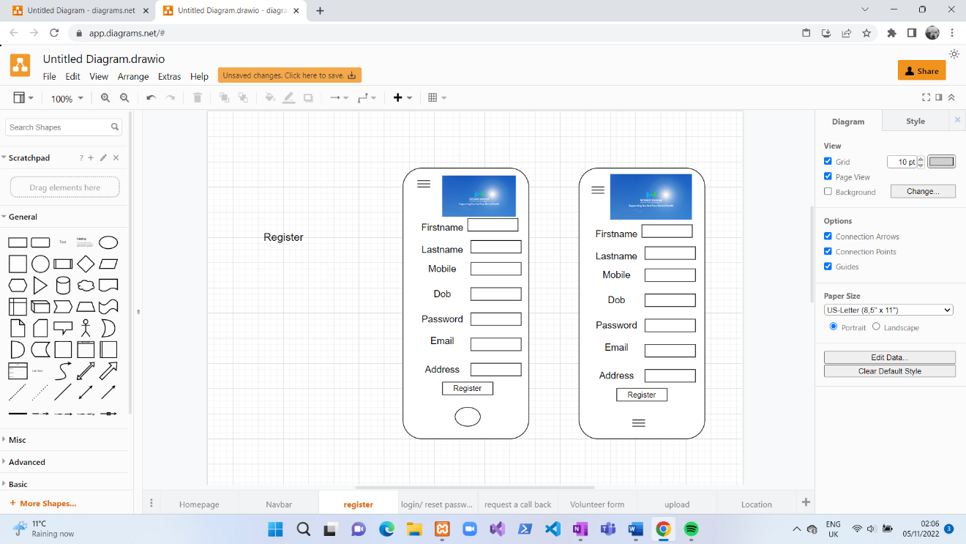

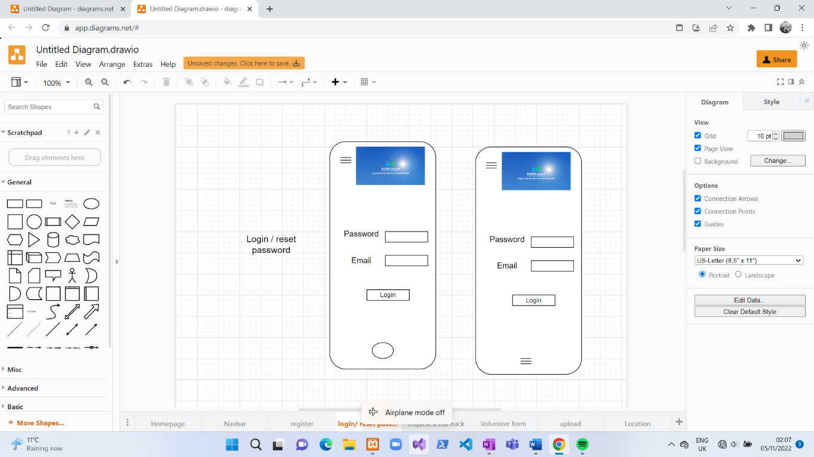

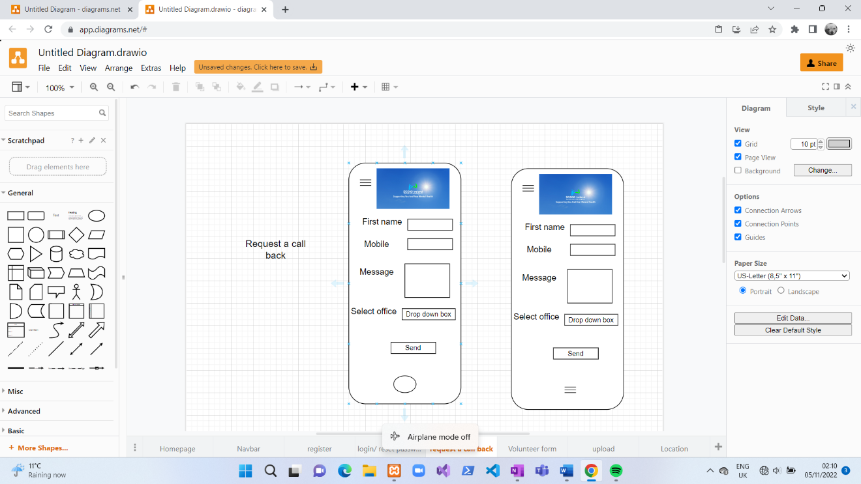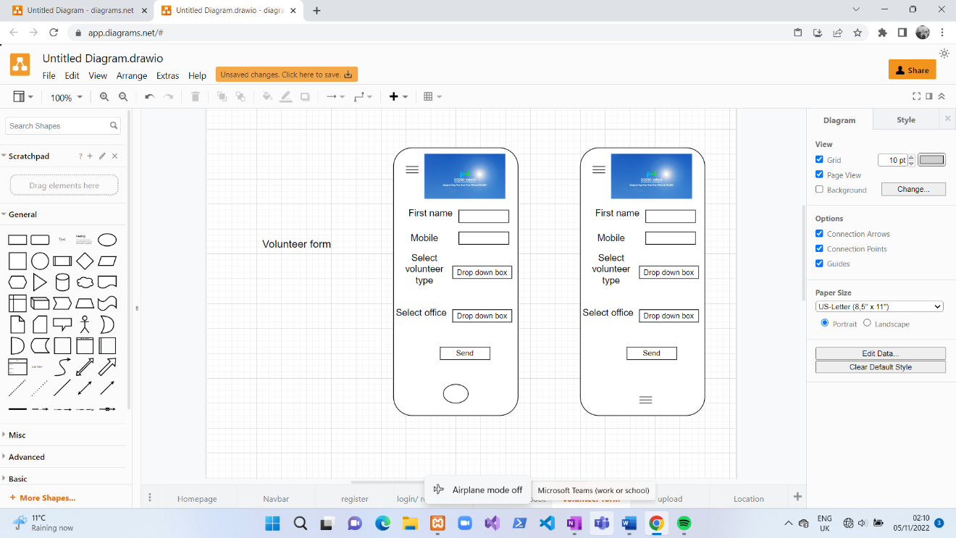

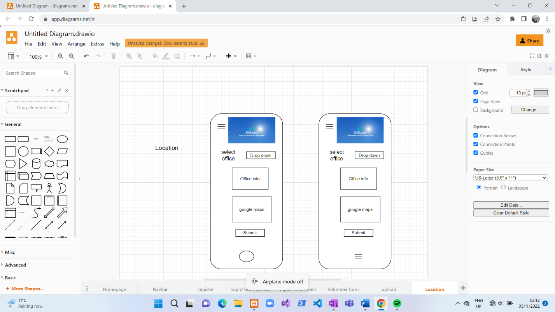

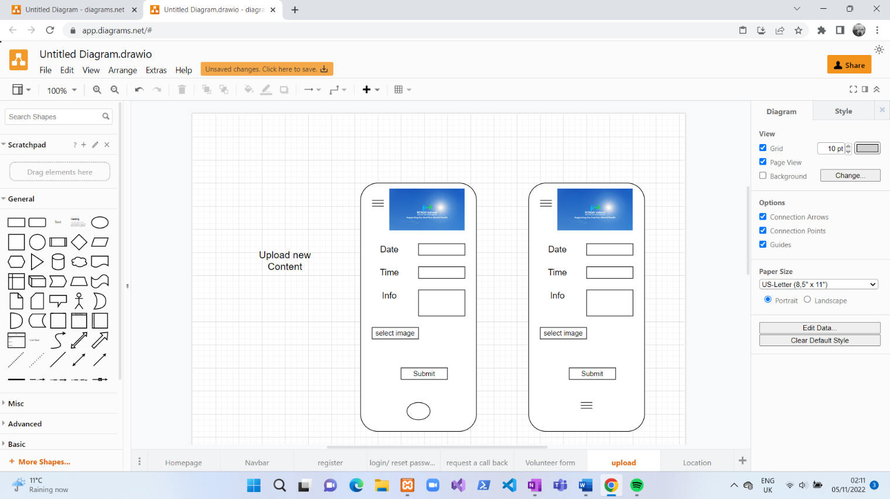

## **Frontend Design**

The developer chose to use Visual Studio IDE as it supports various programming languages, including HTML, CSS, JavaScript, and TypeScript. It also supports other language extensions and allows it to work with a wide range of programming languages. In addition, Visual Studio offers numerous IDE features such as code navigation, debugging, integrated terminal support, and development workflows for the developer to write, test, and debug code. Finally, visual Studio's extensibility allows developers to customise the editor to meet their needs and integrate it with other tools and services using various plugins, extensions, and add-ons.

Front-end design is critical to cross-platform application development using Ionic and Angular. Designers must ensure the application looks and functions nicely across all devices when using Ionic and Angular. Implementing user-friendly features like straightforward typography, well-placed buttons, and navigation enhances the user experience.

## **Architecture pattern/Design**

The Model-View-Controller (MVC) architecture pattern can be an effective design pattern for a cross-platform application that integrates multiple functionalities, such as a motivational quote generator, roster management, event creation/editing/deleting, call back request, and volunteer application, in addition to using Google Maps API.

In an Ionic and Angular cross-platform application with these features, the MVC pattern was used to structure the code to separate the different functionalities and allow for easy maintenance, scalability, and testing.

The model would handle data and business logic for each feature. For example, the Quote Generator module would include a database of motivational quotes, the Roster module would contain data about team members and their schedules, the Event module would handle the creation and management of events, and the Volunteer module would store information about volunteers and their roles of which they want to apply for

The view would contain all the user interface components related to each feature, such as the Quote Generator display, Roster table, Event Calendar, and Volunteer application form. In addition, each view would be responsible for presenting the data in a clear and organised way to the user.

The Controller would handle user input and communication between the Model and View. For example, when a user requests a new quote from the Quote Generator, the Controller would retrieve the data from the Quote Generator module, update the view with the new quote, and potentially store the request in the model for later analysis. Likewise, when a user applies to volunteer, the Controller handles the form submission, validates the input, and stores the new volunteer data in the model.

Using the MVC pattern, the different functionalities of the application can be cleanly separated and organised, reducing the likelihood of code conflicts or bugs. The model also makes it easier to add or remove features in the future without affecting the rest of the codebase. Additionally, using MVC patterns can help facilitate the developer by making the code more readable and understandable.

In conclusion, utilising the MVC pattern in an Ionic and Angular cross-platform application that incorporates Google Maps API, motivational quote generator, roster management, event creation/editing/deleting, call back request, and volunteer application can help development, improve code maintainability, and enhance the user experience.

## **Database Design**

## **Authentication**

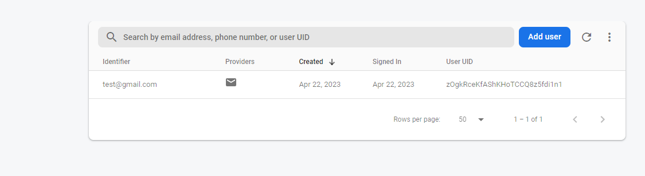in the authentication section in Firebase, you can enable different authentication factors, and when a user's information is inserted into the database, their password is encrypted and becomes unreadable to a hacker. You can also use sign-in methods in Firebase, as seen below in the images. In, Firebase, you have the option for a different authentication login, but in this project, I have selected that the user logins in using their email and password. You can see in the image below the different types of authentications.

## **Fire store Database**

As you can see in the database I am using for a non-relational, there are three sections, collection, document, and fields. In, Firebase, you can see below that it stores all of its data in the form of collections instead of tables, and the collection consists of documents; each document has a field with values like key-value pair. A field can be made up of different types, such as strings, numbers, arrays, Booleans etc., but I will be using strings and numbers in this database.

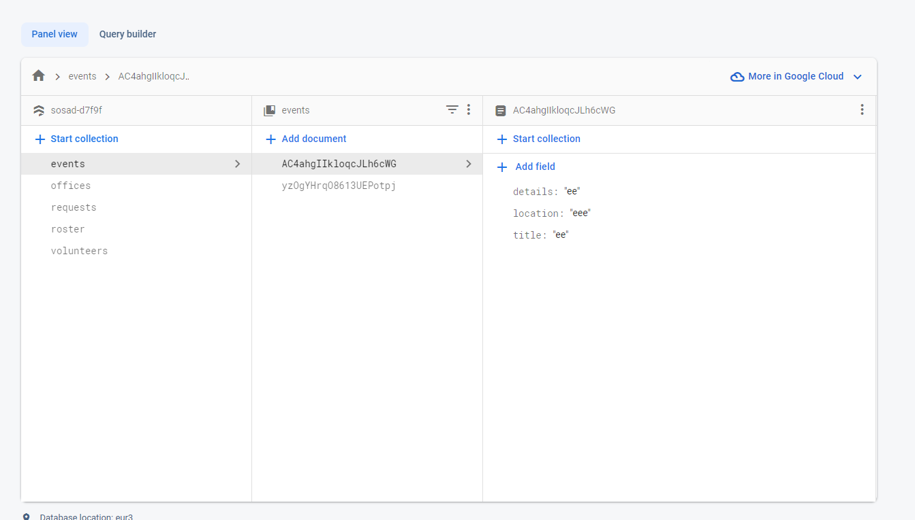

## **Realtime Database**

In the real-time database section of Firebase, it has been used for the chat service of the application to store the chats being had between the client and the staff; the messages should be encrypted so that they are not readable to anyone if they manage to get onto the database. With the rules of GDPR, messages should not be stored.

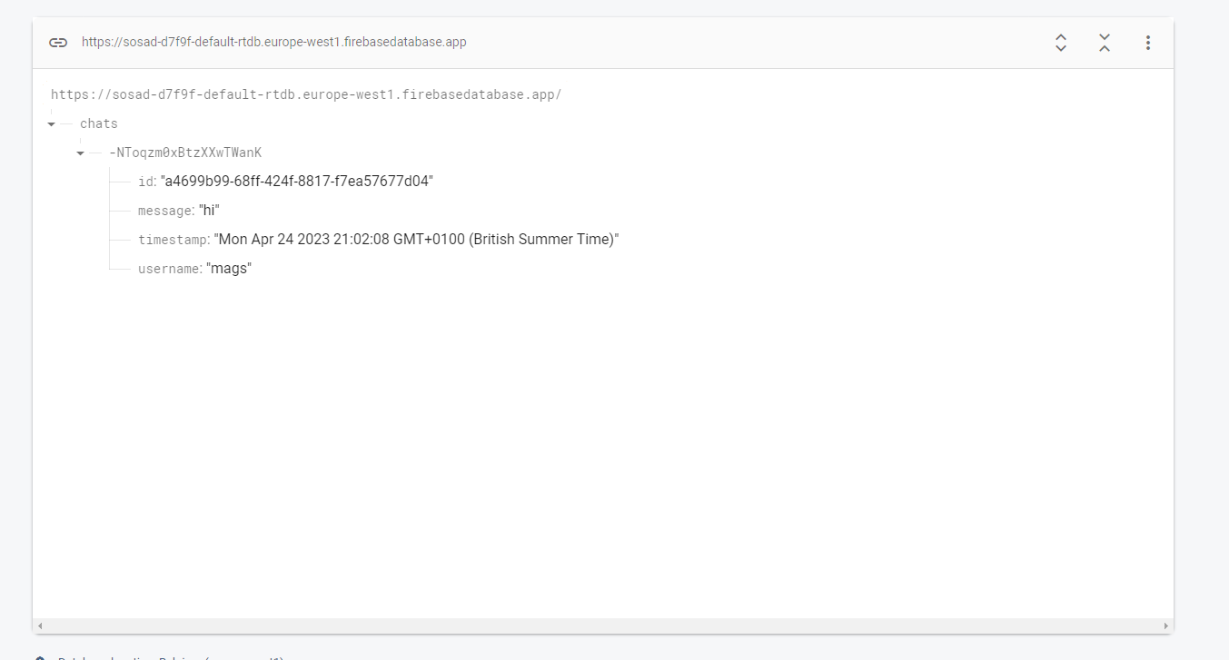

## **Storage**

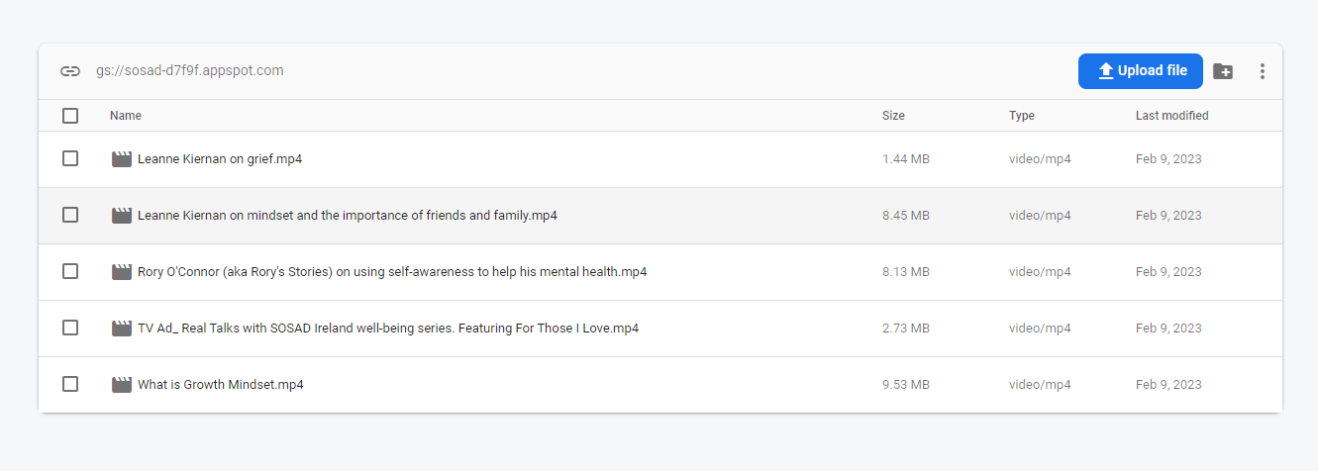The videos from the actual talks are stored in the storage section and displayed in the application so the user can watch them at their leisure.

## **Implementation**

## **How you implemented it**

Implementing a cross-platform application using Google Maps API, CRUD events, staff rosters, volunteer application forms, request a call back using Firebase, and chat service using Real-time Database in Firebase can improve the application's overall functionality and provide a more engaging user experience. For example, Google Maps API can provide location-based services, such as displaying maps, calculating routes, and providing directions to the user. In addition, Firebase can be used for CRUD operations on events and staff roster data, making data management and updating more manageable.

A volunteer application form and a call-back request feature can also be created using Firebase, allowing users to request a call-back from a staff member or apply as a volunteer. In addition, the data collected can be stored in Firebase, making it easy for staff to manage and respond to user requests. Moreover, a chat service using Real-time Database in Firebase and web sockets can be implemented, allowing users to communicate in real time within the application. This can provide a more interactive user experience and enhance the application's overall functionality.

By integrating these features, cross-platform applications can provide consumers with a more interactive and engaging experience while also enhancing their overall functionality and usability.

## **Environment Setup**

Developers are looking for a more effective way to create a cross-platform project that can leverage the power of Ionic and Angular, two prominent frameworks that work together to provide a smooth development experience. To develop a cross-platform application, you must download and install many critical tools and dependencies.

To setup an environment for developing a cross-platform application using ionic and angular the developer will need to follow the following steps.

## **Install Node.js**

## Download and install the latest LTS (Long Term Support) version of Node.js from the official website: https://nodejs.org/

## **Install npm (Node Package Manager)**

## npm comes bundled with Node.js. Make sure it's installed by running the following command in your terminal or command prompt:

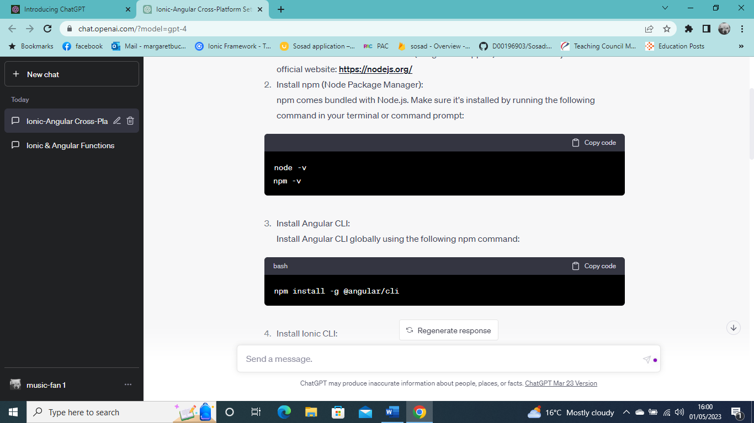

1. **Install Angular CLI:**

Install Angular CLI globally using the following npm command:

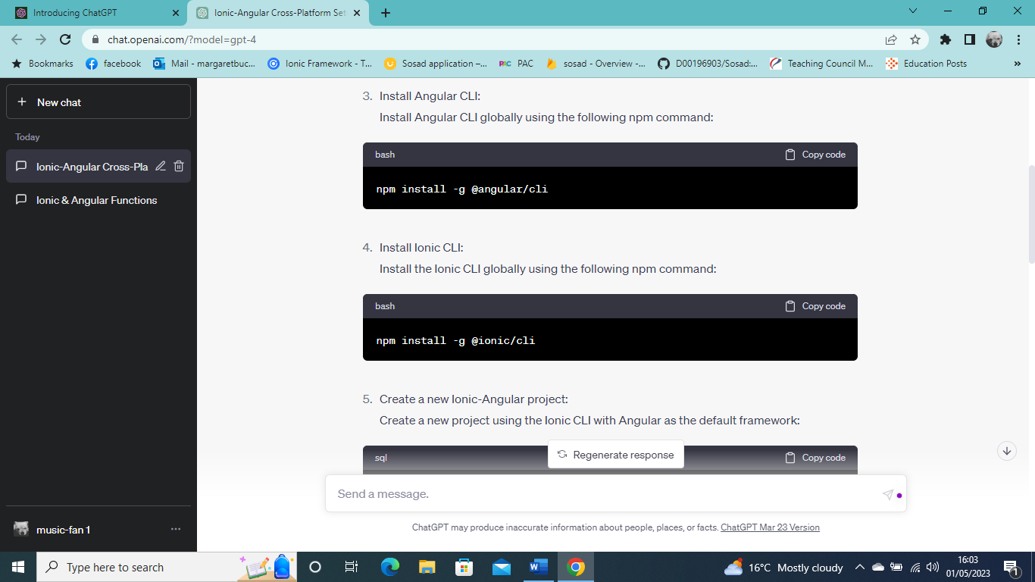

1. **Install Ionic CLI**

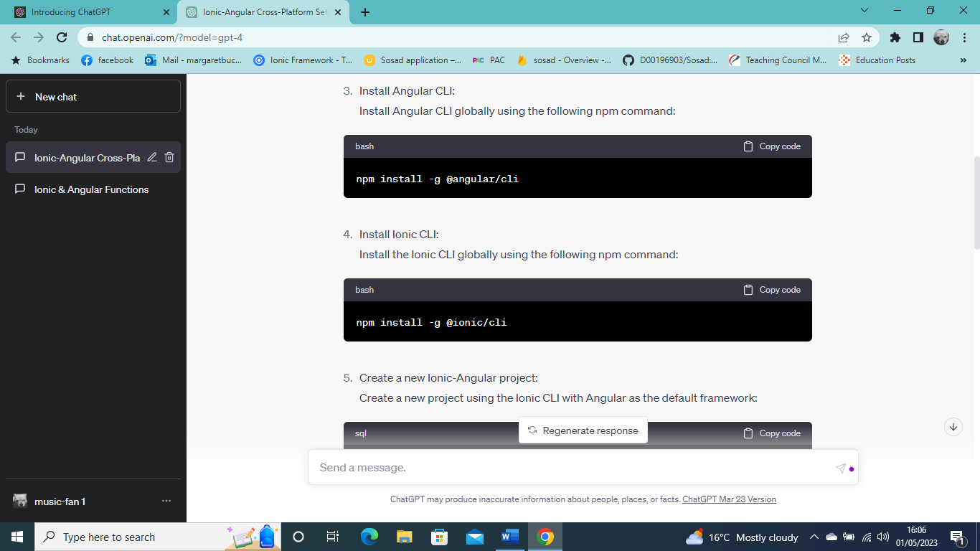Install the Ionic CLI globally using the following npm command:

1. **Create a new Ionic-Angular project.**

Create a new project using the Ionic CLI with Angular as the default framework:

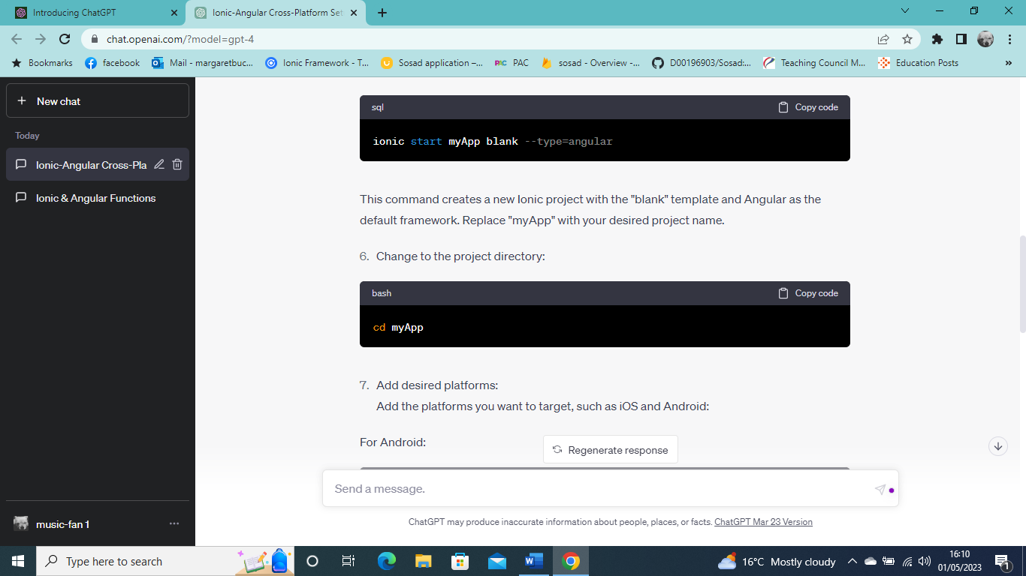

This command creates a new Ionic project with the "blank" template and Angular as the default framework. Replace "myApp" with your desired project name.

1. **Change to the project directory.**

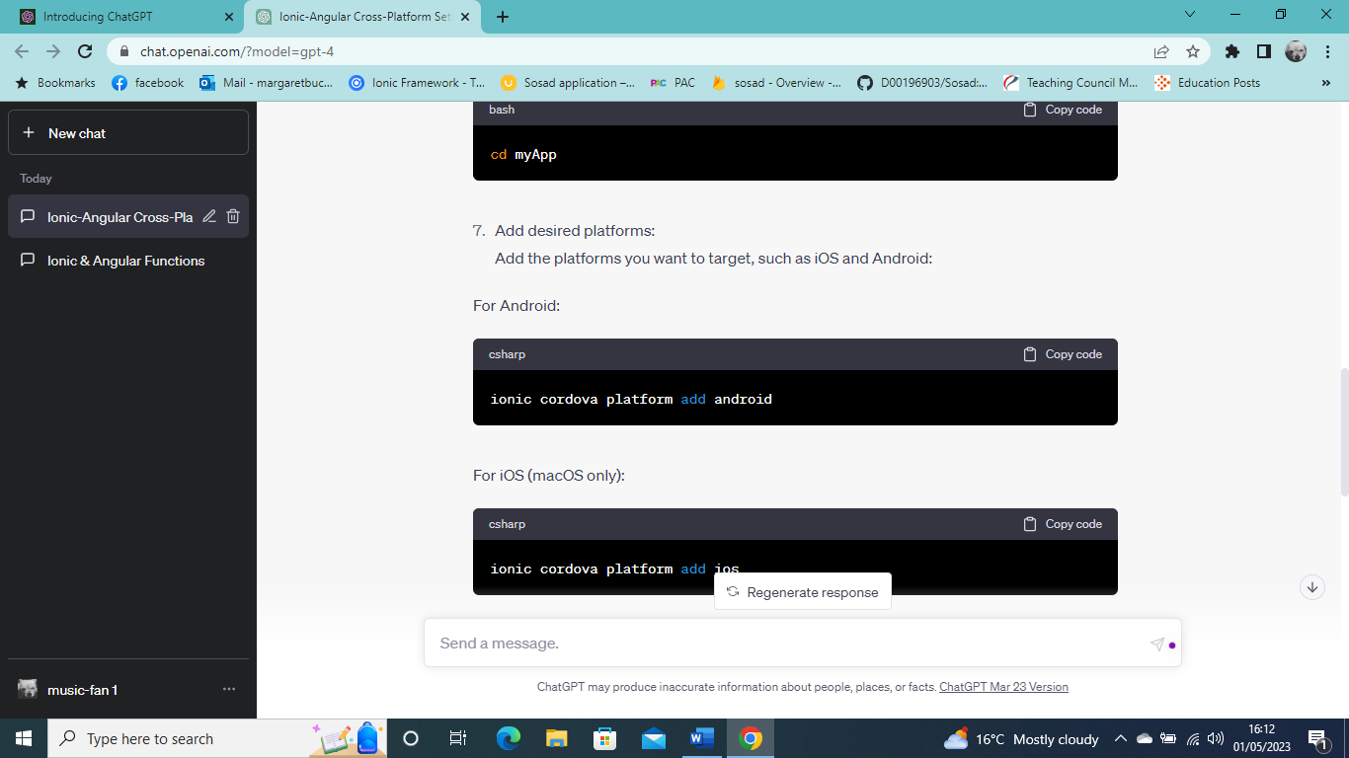

1. **Installing capacitor**

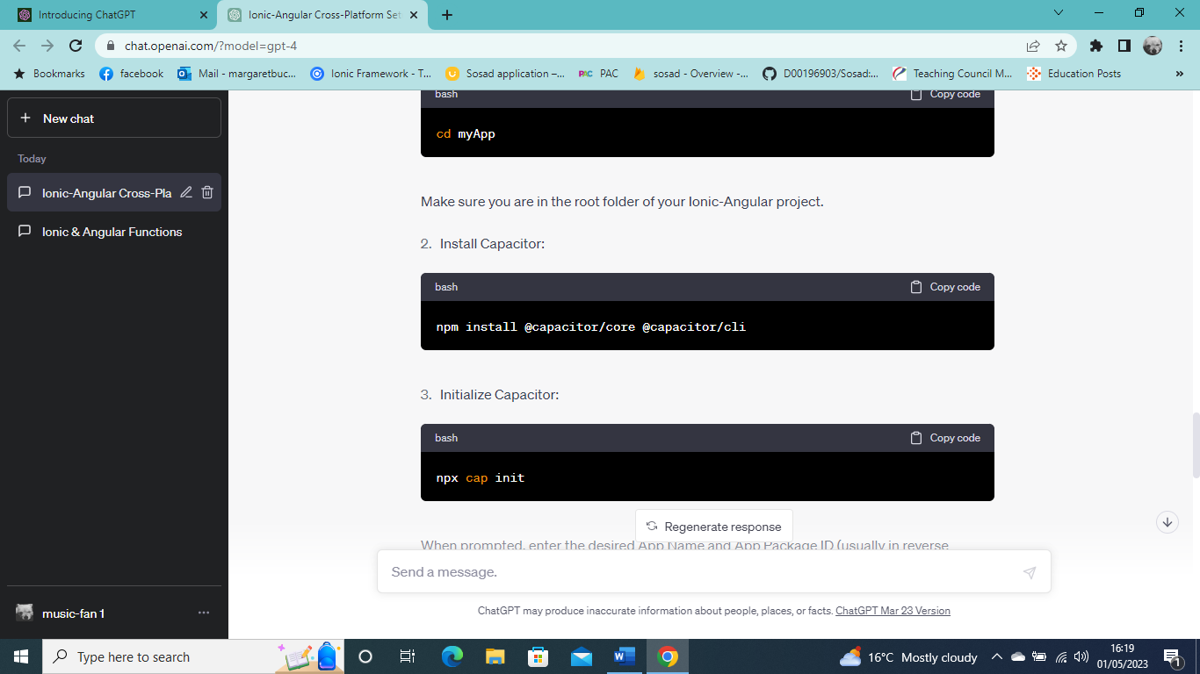

1. **Initialize Capacitor**

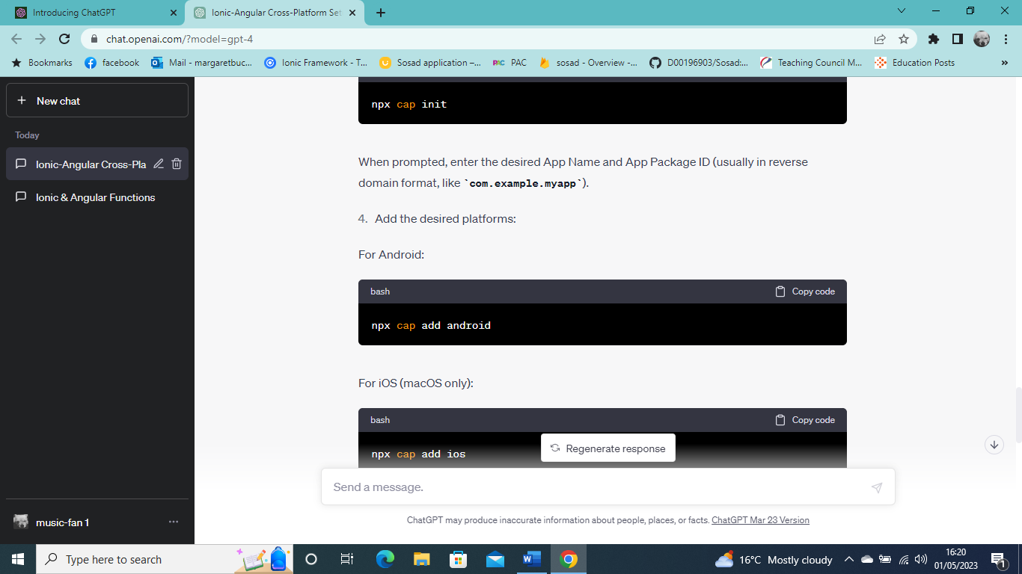

1. **Adding the desired platforms.**
2. **For Android.**

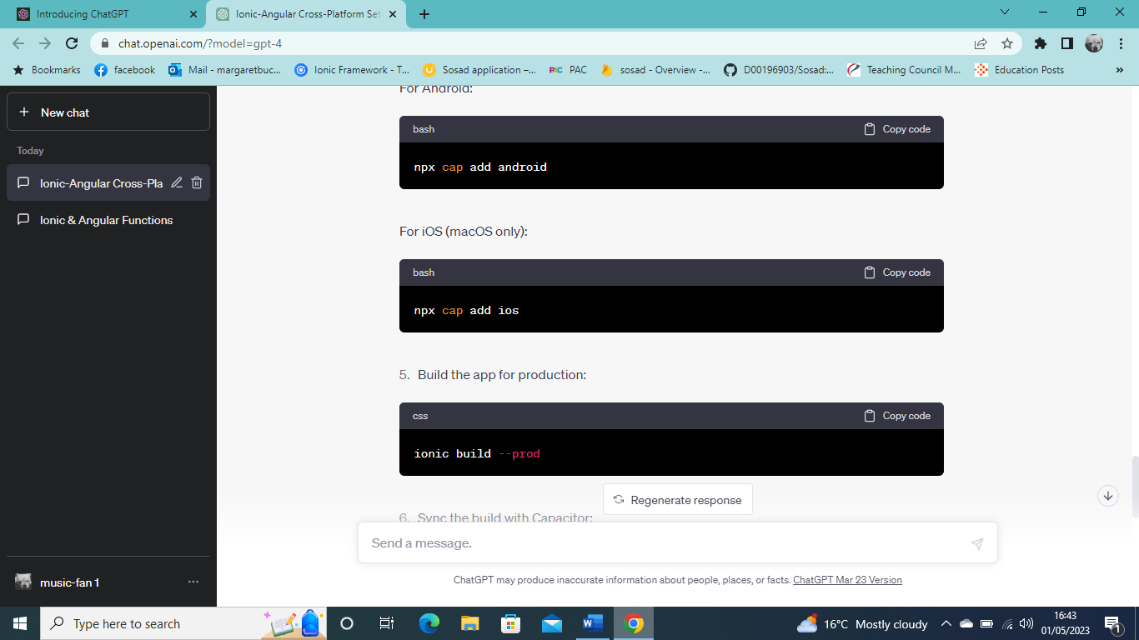

1. **iOS**



1. **Build the app for production.**



1. **Sync the build with Capacitor.**

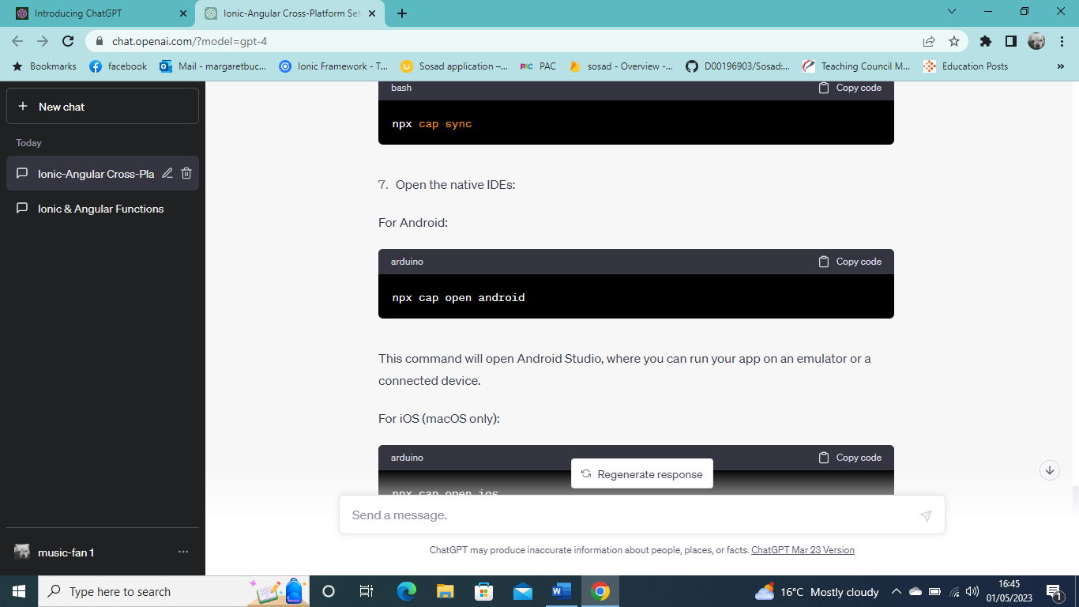

1. **Open the native IDEs:**



This command will open Android Studio, where you can run your app on an emulator or a connected device.

1. **IOS**

This command will open Xcode, where you can run your app on an iOS simulator or a connected device.

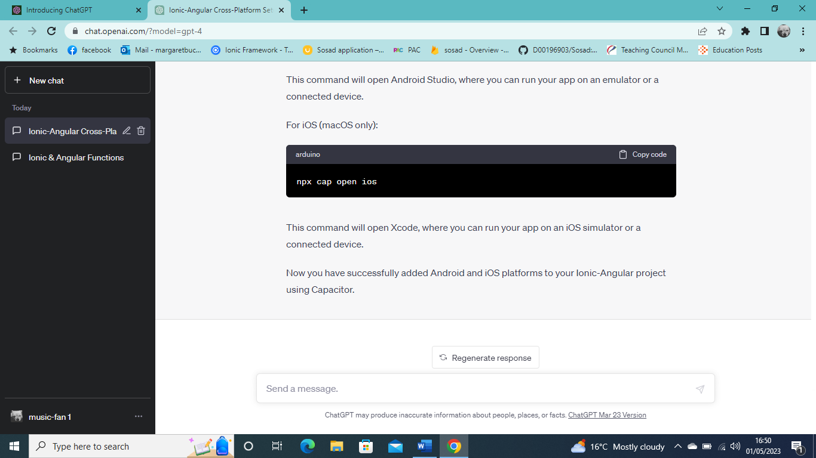

Now you have successfully added Android and iOS platforms to your Ionic-Angular project using Capacitor.

## **Functionality**

Functions are critical to developing cross-platform applications using Ionic Angular, Google Maps APIs, Motivational Quote API, and Firebase. For example, a function can retrieve a motivational quote from the Motivational Quote API and display it to the user within the application. The Google Maps API can be used to show the different office locations once one of the offices has been selected. Firebase can be used to manage and store the data that the user has inserted into the application. The data from the staff will also be stored in the database.

The functions can optimise performance by minimising data transfer and reducing server load. For example, a function can be designed to retrieve only the necessary data from the Firebase database, reducing the amount of data that needs to be transferred over the network.

You can also use actions to implement security features, such as user authentication and authorisation. Authenticate users and manage access to different application parts with Firebase functions.

**Key features:**

The application's key features include finding the location of the different offices using an API; it also provides information about the organisation's services and enables users to get the required assistance. Users will be able to apply to volunteer at any of the office's locations; Users will be able to get a random motivational quote, and users will be able to use the chat service to speak to a trained staff member through the application. The staff can view the request a call, applicants who apply to be a volunteer, and create, edit, and delete events. The staff can put their availability into the calendar so the supervisor or the general manager can see who is available and when.

**User interface:**

The user interface for the cross-platform application was built using ionic and angular; it will be designed to be easy for those non-tech savvy users. The application will be designed for IOS and Android, giving the user/s a continuous experience when using the application. The UI design will be clean and appealing to users with easy navigation, allowing users to move around the application. The application will integrate two APIS, one for google maps and the other for the motivational quote generator. The APIS will give users real-time information on office locations and quotes. This application will be designed to provide users with an enjoyable and engaging, and straightforward experience.

* **User/client flow**

A none staff member will not have to register and login to use this application when it is downloaded, when a user opens up the application, they will be greeted with 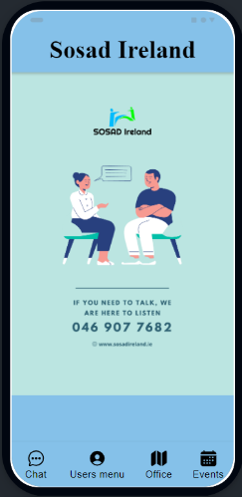

The user will have their own home screen menu where they have the option to navigate around the application from this menu.

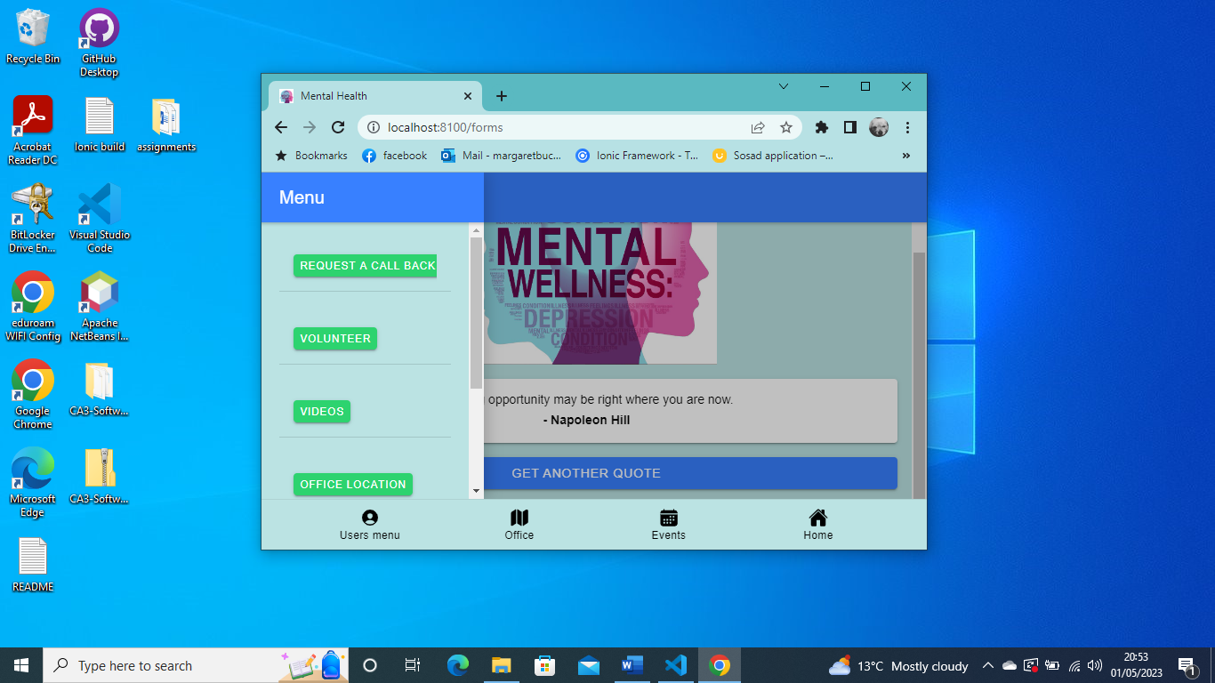

**Users/staff flow**

when the application is downloaded, all staff will have to register and login using this application.to register and login to use the application the staff will need to click on the image that is on the home screen menu and once the staff is registered and logged in they will be redirected to the staff menu page.

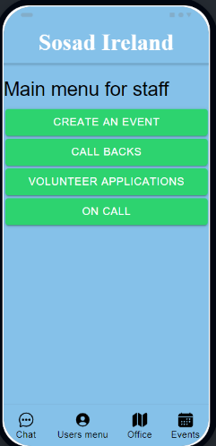

* **Technical specifications**

The cross-platform application will be developed using TypeScript, HTML, and CSS, with a focus on delivering a consistent user experience across all platforms. To achieve this, the application will utilize third-party libraries and frameworks such as Ionic, and Angular, which offer a range of tools and features for building cross-platform apps. The application will be designed so it adapts to different screen sizes and orientations. The application will be thoroughly tested using gherkin and unit testing, to ensure its stability and reliability across different platforms and devices. The result will be a robust, user-friendly, and scalable application that provides a seamless experience for users across all platforms.

* **Data storage**

Firebase provides a dependable and scalable data storage solution for cross-platform applications. Firebase is a cloud-based database service that is accessible from any platform, including iOS, Android, and web apps. The Firebase Realtime Database is a NoSQL database that stores data in JSON format and enables real-time client synchronisation. This means that any changes to the database performed by one client are immediately mirrored on all other connected clients. Firebase also provides a safe place to store user authentication and permission information. The Firebase Authentication service offers a variety of authentication methods, such as email and password, phone number, and social media logins. This guarantees that user data is securely preserved, and only authorised individuals have access to it. Additionally, Firebase's Cloud Storage service offers scalable storage for media files such as images and videos. Firebase's Realtime Database, Authentication, and Cloud Storage services work together to create a robust and convenient solution for data storage in cross-platform apps.

* **Testing**

When developing a cross-platform programme, testing is essential to ensure its functionality and user experience across multiple platforms. Gherkin will be used since it is a popular testing framework that defines software behaviour in a systematic and comprehensible manner. Gherkin's language is straightforward, making it an ideal tool for developers. By creating Gherkin scenarios, developers may create automated tests that are straightforward to maintain and can run on multiple platforms. I will also be performing unit testing; unit testing allows for developers to test individual code units independently. Developers may quickly identify and repair any issues that arise by isolating individual bits of code before they affect the broader application. Unit testing is extremely useful for cross-platform apps.

## **Gherkin**

Gherkin is a domain-specific language (DSL) developed to describe software system behaviour in a human-readable way. It is essential to Behaviour Driven Development (BDD), a software development process that stresses collaboration between developers and testers.

The Gherkin language has a simple, structured syntax that allows developers and testers to specify features, scenarios, and step definitions using the terms Given, When Then, And, and But. This language allows for explicit communication and understanding of the intended behaviour of the product, making it easier to develop automated tests and reducing misconceptions among team members. (UN, What Is Gherkin & How Do You Write Gherkin Tests?, 2023)

**Key Components of Gherkin**

1. **Feature** A feature is a high-level description of software functionality that often includes a title and a brief explanation. It describes the system's or a specific component's principal purpose and assists developers in understanding the context of the functionality. (UN, What Is Gherkin & How Do You Write Gherkin Tests?, 2023)
2. **Scenario:** Scenarios are specific examples of how a feature should act in various circumstances. Each scenario is made up of a set of stages stated in the Given, When, then format that define the starting point, the action taken, and the intended conclusion. (UN, What Is Gherkin & How Do You Write Gherkin Tests?, 2023)
3. **Step Definitions:** Step definitions are the code implementations of a scenario's various steps. They link the Gherkin language and the test automation code, allowing Gherkin scenarios to be run as automated tests. (UN, What Is Gherkin & How Do You Write Gherkin Tests?, 2023)
4. **Background:** The background section establishes a shared context for all scenarios inside a feature. It is run before each scenario and aids in reducing repetition in Gherkin scenarios. (UN, What Is Gherkin & How Do You Write Gherkin Tests?, 2023)
5. **Scenario Outline:** Scenario outlines are used to describe scenarios with similar structures but differ in input values or predicted outcomes. (UN, What Is Gherkin & How Do You Write Gherkin Tests?, 2023)
6. **Tags:** Tags are used to organise and categorise features or scenarios. They enable you to run individual tests selectively, making it easier to organise test suites and focus on specific functionalities. (UN, What Is Gherkin & How Do You Write Gherkin Tests?, 2023)

**Advantages**

* **Enhanced communication**

Gherkin language encourages straightforward communication between developers and testers, ensuring that everyone has a shared knowledge of the desired behaviour of the project.

* **Collaboration**

Gherkin supports team collaboration by enabling shared ownership of the product and contributions from diverse views.

* **Easy to read and write**.

Gherkin's simple syntax allows non-technical testers to understand and contribute to the software's specs.

* **Test automation**

Gherkin scenarios can be readily turned into automated tests using tools like Cucumber, Spec Flow, or Behave, increasing the testing process's efficiency.

**Disadvantages**

* **Learning curve**

Team members unfamiliar with Gherkin or BDD may require additional time to master the syntax and best practices. In the short run, this early learning curve can stifle development.

* **Overhead and maintenance**

Writing Gherkin scenarios and maintaining them up to date with changing software needs might add extra work. In addition, maintenance gets more time-consuming as the test suite expands, slowing the development process.

* **Limited expressiveness**

The simplicity of Gherkin is one of its virtues, yet it can also be a hindrance. For example, complex logic, calculations, or data manipulations might require more work to describe clearly in Gherkin, resulting in workarounds or compromises in the language's readability.

* **Integration with existing processes**

Incorporating Gherkin and BDD into a current development process may necessitate considerable tooling, workflows, and team dynamics modifications. This can be disruptive and time-consuming, especially if the organisation needs to prepare.

* **Dependency on tools**

Gherkin relies on tools like Cucumber, Spec Flow, or Behave to execute scenarios as automated tests. However, this introduces a dependency on these tools, which may have limitations, and requires the team to stay updated with the latest developments and best practices.

* **Incomplete test coverage**

Gherkin focuses on describing behaviour from a user's perspective, which might only cover some possible edge cases or lower-level unit tests. Therefore, combining Gherkin testing with other testing approaches is essential to ensure comprehensive test coverage.

Despite these drawbacks, Gherkin testing can still be a useful addition to your development process if implemented carefully. Therefore, it is essential to carefully consider the trade-offs and ensure that your team is prepared to invest the necessary time and effort in learning and adapting to the Gherkin language and BDD approach.

Gherkin testing plays a crucial role in BDD by providing a common language for describing software behaviour. This improves communication, collaboration, and overall quality of the software while streamlining the testing process.

Each scenario comprises three parts Given, When, and Then. Given describes the initial conditions for the scenario, then describes the actions that are taken, and then describes the expected outcome. These components are written in natural language so that technical and non-technical developers can easily understand them.

**Here is a sample of some of the Gherkin tests that I have carried out.**

**This is a Gherkin feature file describing the User Registration feature for the application.**

The feature file starts with a brief description of what the feature is about. In this case, it's about allowing new users to register for an account to access the application with their credentials. The Background section sets the initial conditions for all scenarios in the feature. In this case, it's assuming that the user is on the registration page.

**There are four scenarios in this feature file:**

* **Filling out the registration form with valid details**

This scenario describes the expected behaviour when a user fills out the registration form with valid details such as a valid email and password. A new user account should be created with the provided email and password if the form is submitted successfully.

* **They are successfully registering a new user.**

This scenario describes the expected behaviour when a new user account is created successfully. If the registration is complete, the loading indicator should be dismissed, and the user should be redirected to the home page.

* **Form validation with missing email or password**

This scenario describes the expected behaviour when a user tries to submit the registration form without providing an email or password. In this case, a toast message indicating the missing information should be displayed, and the form should not be submitted.

* **Error during user registration**

This scenario describes the expected behaviour when there is an error while registering the user. In this case, the loading indicator should be dismissed, and a toast should be displayed with the message "Enter Input".

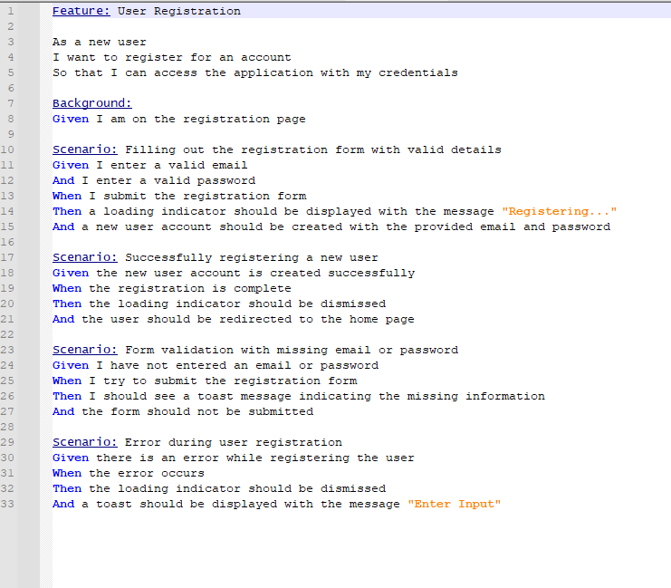

**This is a Gherkin feature file describing the User Login feature for the application.**

The feature file starts with a brief description of the feature. In this case, it is about allowing new users to log in to access the application with their credentials. Next, the Background section sets the initial conditions for all scenarios in the feature. In this case, it's assumed that the user is on the login page.

**There are three scenarios in this feature file.**

* **Successful login**

This scenario describes the expected behaviour when a user enters a valid email and password and clicks the login button. If the email and password are authenticated against the stored credentials, the loading indicator should be dismissed, and the user should be redirected to the "buttons" page.

* **Failed login due to incorrect email or password**

This scenario describes the expected behaviour when a user enters an incorrect email or password and clicks the login button. If the email and password fail to authenticate against the stored credentials, a toast with the message "Enter Email" should be displayed.

* **Failed login due to incomplete form**

This scenario describes the expected behaviour when a user does not enter an email or password and clicks the login button. In this case, a toast with the message "Enter email" or "Enter password" should be displayed, and the user should not be redirected to the "buttons" page.

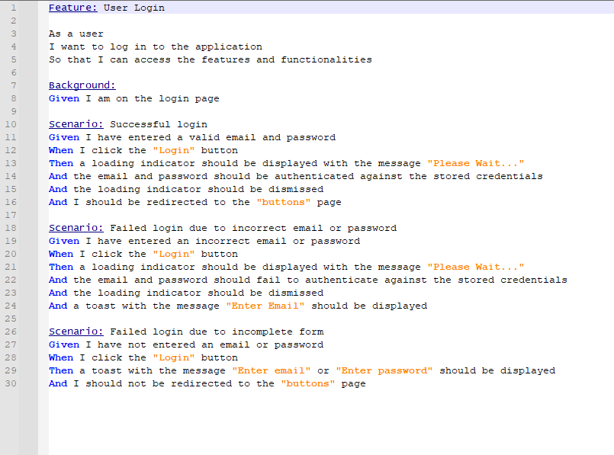

**This is a Gherkin feature file describing the application's Display Offices on Google Maps feature.**

The feature file starts with a brief description of the feature. In this case, it is about allowing users to view the offices on Google Maps so that they can see their locations and access their information. Next, the Background section sets the initial conditions for all scenarios in the feature. In this case, it's assumed that the user is on the maps page.

**There are three scenarios in this feature file.**

* **User views the map with no office selected.**

This scenario describes the expected behaviour when a user has not selected an office from the dropdown menu. If the map is displayed, it should be centred at coordinates (1.0667172756631198, 103.96214500683499) with a zoom level of 5, and no markers should be displayed.

* **The user selects an office from the dropdown menu.**

This scenario describes the expected behaviour when users select an office from the dropdown menu. If the map is displayed, it should be centred on the selected office with a zoom level of 7, and a marker should be displayed for the selected office. In addition, the heading should display the selected office's country, and the description should display the selected office's information.

* **User selects a different office from the dropdown menu:**

This scenario describes the expected behaviour when a user selects a different office from the dropdown menu. If the map is displayed, it should be centred on the newly selected office with a zoom level of 7, and the previously displayed marker should be removed. A new marker should be displayed for the newly elected office, and the heading and description should update to display the newly selected office's country and information.

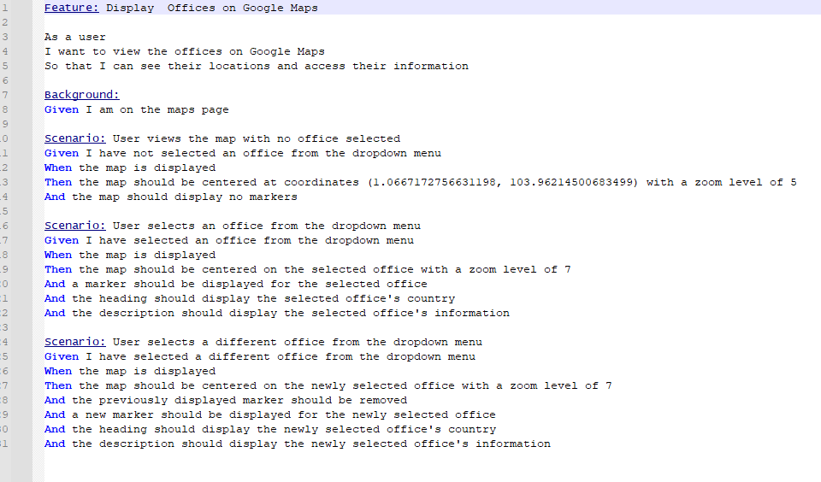

**This is a Gherkin feature file describing an application's Display Office Details feature.**

The feature file starts with a brief description of the feature. In this case, it is about allowing users to view the office details to access the coordinator, address, location, email, and contact information. The Background section sets the initial conditions for all scenarios in the feature. In this case, it has assumed that the user is on the office page.

**There are three scenarios in this feature file.**

* **Loading the office details**

This scenario describes the expected behaviour when the office details are not loaded. If the user visits the office page, a loading indicator should be displayed with the message "Please Wait...", and the office details should be fetched from the Fire store collection "offices".

* **Displaying the fetched office details**

This scenario describes the expected behaviour when the office details are successfully fetched. Suppose the office details are ready to be displayed. In that case, the loading indicator should be dismissed, and the office details should be displayed, including the coordinator, address, location, email, and contact information.

* **Error while fetching office details.**

This scenario describes the expected behaviour when there is an error while fetching the office details. In this case, the loading indicator should be dismissed, and a toast should be displayed with the message "Enter Email".

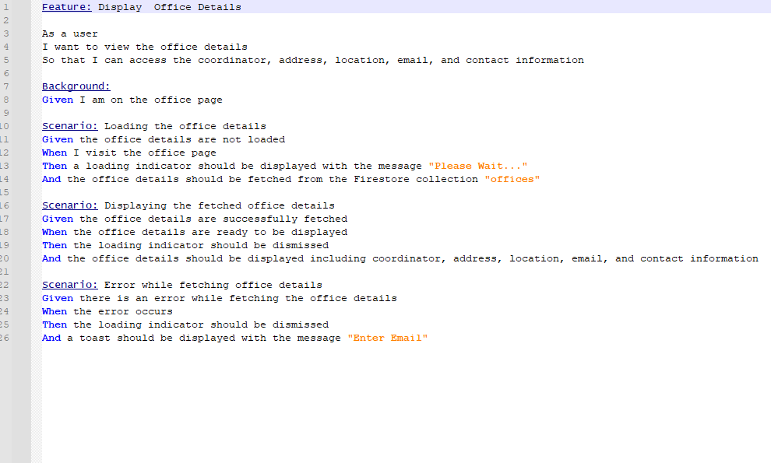

**This is a Gherkin feature file describing the Chat Application feature for the application.**

The feature file starts with a brief description of the feature. In this case, it is about allowing users to view and send chat messages and receive new messages in real-time. Next, the Background section sets the initial conditions for all scenarios in the feature. In this case, it has assumed that the user is on the chat page.

**There are three scenarios in this feature file.**

* **Display existing chat messages.**

This scenario describes the expected behaviour when existing chat messages are in the database. Users who visit the chat page should see the existing chat messages displayed chronologically.

* **Send a chat message.**

This scenario describes the expected behaviour when a user sends a chat message. If the user enters a username and message and clicks the "Submit" button, the message should be sent to the database with a timestamp and a unique ID. The message should appear in the chat window, and the username field should retain the entered username.

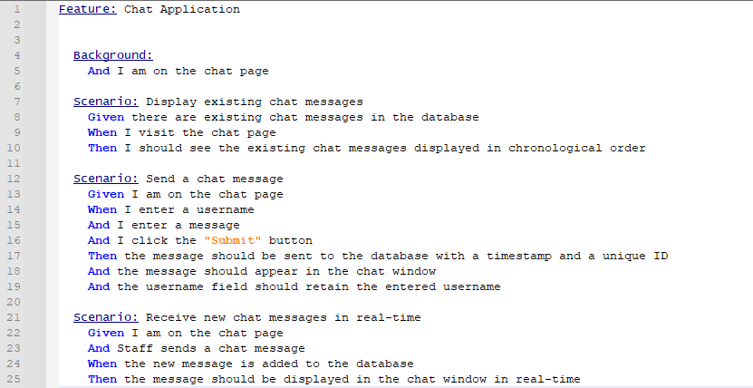

* **Receive new chat messages in real time.**

This scenario describes the expected behaviour when a user receives new chat messages in real-time. For example, if the user is on the chat page and a staff member sends a chat message, the new message should be added to the database and displayed in the chat window in real-time.

**Cross-platform compatibility**

The application's cross-platform interoperability is crucial for ensuring a consistent user experience across platforms. The application will be built with frameworks such as ionic and angular, allowing it to run on both the Android and iOS platforms. Furthermore, the application will be built with HTML, CSS, and TypeScript, allowing it to be easily adapted to work on web platforms. The user interface of the programme will be adaptable, responding to multiple screen sizes and orientations regardless of platform.

This will be achieved by using CSS media queries and responsive design principles. The application's layout will adjust dynamically to provide an optimal user experience on any device. The application will be thoroughly tested across different platforms to ensure its compatibility and functionality, providing a seamless experience for users regardless of the platform they use. Overall, the cross-platform compatibility of the application will be a key factor in delivering a high-quality user experience. This will be accomplished through the use of CSS media queries and responsive design concepts. The layout of the programme will alter dynamically to deliver the best user experience on every device. The application will be rigorously tested across several platforms to verify compatibility and functioning, ensuring a consistent user experience regardless of platform. Overall, the application's cross-platform interoperability will be critical in offering a high-quality user experience.

* **Future developments:** In the future I would like to add the following features to the application.

## **Agile Development**

Agile development emphasises flexibility, adaptability, and customer satisfaction in its iterative and collaborative approach to software development. When the development is broken down into brief iterations, or sprints, using an agile methodology, with each sprint concentrating on providing a particular set of features or capabilities. Delivering functional software at the conclusion of each iteration is the objective.

An agile approach was used in the development of this project. Iterations were one weeklong. Meetings were held at the end of each iteration to assess progress and plan for the next iteration. This approach enabled the developer to collaborate closely with their supervisor and respond quickly to changing requirements and priorities. The agile development process was efficient and effective and helped align the application with set aims.

## **Conclusion**

It can be concluded that the development of a cross-platform application using google maps API, motivational quotes, crud events, staff rosters, volunteer application forms, request a call back using Firebase and the chat service using a real-time database and firestore database in Firebase has significantly improved the applications overall functionality and provided a more engaging user experience. Furthermore, the use of ionic and angular frameworks, along with the integration of Firebase for data storage and management, has allowed the developer to create a user-friendly and responsive application that caters for various platforms and devices.

The application's development followed an agile approach, prioritising the user's satisfaction, adaptability, and flexibility. The MVC pattern was implemented, enabling a clean separation and organisation of the application's different functionalities, reducing potential code conflicts or bugs and enhancing the application's scalability. In addition, using the Gherkin language can significantly improve the testing process for the cross-platform application.

The choice between cloud services, database types and real-time databases depends mainly on the application's specific needs. The NoSQL and MYSQL database offer a unique advantage based on the application's requirements. In contrast, Firebase's real-time database and storage features are instrumental to the functionality and security of the application.

The report shows the potential of using advanced technologies, frameworks, and APIS to create robust, user-friendly, and scalable cross-platform applications that deliver a consistent and engaging user experience across different platforms and devices. In addition, plans to add new features to the application, such as push notifications and improved search functionality, will enhance the user experience and improve the application's overall functionality.

Overall, the application received positive feedback across various age groups and devices, particularly from users aged 35-44 and 55-64 using phones and tablets. These users were highly satisfied and likely to use the app again and recommend it. However, younger users (18-24) using laptops faced difficulties, indicating potential areas for improvement. All users could complete tasks quickly, demonstrating user-friendly design and functionality, and used the app daily, indicating high engagement. The use of other apps like Netflix, YouTube, SnapChat, Twitter, and Facebook among different age groups suggests the potential for increased engagement through integration. In summary, while the app demonstrates high user satisfaction and engagement, ongoing improvements, particularly for younger laptop users, will be key to enhancing user experience.

## **Appendix**

## **Survey**

**Conducting a Quantitative Survey to Evaluate User Satisfaction with the Developed Application.**

This part of the project aims to better understand user satisfaction with the developed application. The survey will use a quantitative survey to collect data from different user/s. It will focus on assessing various aspects of user satisfaction, including the application's usability and features, using a structured questionnaire/survey with close-ended questions. The survey will be able to identify significant user satisfaction. Ultimately, the key findings will help improve the application and ensure customer satisfaction, thereby increasing the likelihood of its success in the market. (UN, USCLibraries, Last updated: Apr 4, 2023 1:59 PM)

The survey is to determine the factors that impact user satisfaction within the developed application, which is part of the final-year project. To accomplish this objective, a quantitative survey will be conducted to gather data from a range of users, including IOS and Android users using different devices (E: G tablets, laptops, phones). The survey will be a structured questionnaire with a series of multiple-choice questions. It will be developed to assess various aspects of the application, including its usability and features. (Fleetwood, UN)

**Developing a Structured Questionnaire for a Face-to-Face Quantitative Survey of App User Satisfaction.**

A survey review of a user's satisfaction will be conducted to ensure that the survey questions are relevant and practical. This review will provide insights into the critical factors that influence user satisfaction and assist in identifying the specific aspects of the app that will be evaluated in the survey. The survey will be face-to-face with participants. A quantitative survey has a few advantages. For starters, it enables the collection of large amounts of data from many users. Second, employing closed-ended questions guarantees that the data obtained is standardised and easy to interpret. Using specific methodologies, the developer will be able to determine customer happiness. Implementing a quantitative survey is justified since it enables the developer to detect substantial user satisfaction while allowing for efficient and cost-effective data collection. (Fleetwood, UN)

In social research, quantitative surveys are a popular way of data collection. They are often employed to collect numerical data that can be statistically evaluated to detect patterns and trends. This section will identify and discuss the quantitative survey data collection method. This quantitative study chose a structured questionnaire/survey as the data-gathering approach. The questionnaire/survey will be constructed to assess several areas of customer satisfaction, such as app features and app usability. The survey questions will be closed-ended, with multiple-choice answers, allowing the developer to collect standardised data that is easy to examine. This survey will provide insights into the critical factors contributing to user satisfaction. It will aid in identifying the particular aspects of the app that should be reviewed in the survey. The assessment will also aid in ensuring that the survey questions are pertinent and practical. The questionnaire/survey will be divided into numerous sections. The first component will collect demographic information such as age. This data will allow us to spot any patterns or trends in user satisfaction. (Williams, June 14, 2021)

**Section by Section Overview of the Structured Questionnaire for a Face-to-Face Quantitative Survey to Evaluate User Satisfaction with the App.**

The second section will evaluate the product features of the application. The questions will assess the user's satisfaction with features such as search functionality, images, descriptions, and filling out forms. Each question will be accompanied by a rating scale ranging from "easy" to "difficult." The scale will enable us to quantify the user's satisfaction with each feature and compare the satisfaction level of different features. The application's usefulness will be assessed in the third segment. The questions will gauge the user's satisfaction with features such as usability and navigation. Each question will be accompanied with a grading scale once more. The fourth section will gather information about the user's overall satisfaction with the application. This section will include a single question that asks the user to rate their satisfaction level with the application on a scale from one to five. This question will enable us to determine the user's overall satisfaction with the application and provide a benchmark for comparing satisfaction levels between different groups of user/s. (Fleetwood, UN)

The questionnaire/survey's last portion will include open-ended questions that will allow users to submit comments and suggestions for improvement. These questions will allow us to obtain insight into the user's ideas and feelings regarding the application, as well as identify any areas for development that the previous sections did not touch. The sample size and sample selection must be carefully evaluated to ensure the survey's effectiveness. The sample size should be large enough to yield trustworthy results, but not so large that data collection and analysis become difficult. The questions will be chosen to guarantee that the survey encompasses a varied spectrum of people. (Fleetwood, UN)

**Limitations and Alternative Approaches for Future Quantitative Surveys to Evaluate User Satisfaction with the App.**

This survey aims to identify the elements that influence user satisfaction with the built application. The survey will be used to collect information from a variety of people. A quantitative survey is justified because it provides efficient and cost-effective data collection. The study's findings will help develop the application and assure user satisfaction. Reflecting on the questionnaire/survey process's results, there are a few limits and potential areas for development for future quantitative surveys. The poll was conducted in a specific area, so the results may need to be more generalisable to other areas. An online survey platform might be used to conduct a more varied survey to solve this constraint in future surveys. Another disadvantage is that the survey questions are closed-ended, limiting the variety of responses available to participants. Including open-ended questions in future surveys could provide more detailed information about participants' experiences and opinions.

The survey relied on self-reported data, which may have been skewed. Participants may have hesitated to disclose unpleasant experiences to avoid future survey limits. I could use approaches like observation or follow-up interviews to gather more accurate and detailed information on participants' experiences. One strategy for a quantitative survey that could be used is a mixed-methodologies approach incorporating quantitative and qualitative data collection methods. This could provide a more comprehensive picture of the experiences and perspectives of the participants. Another option would be to conduct more significant research over an extended period to examine participant satisfaction changes with the application over time. This could provide crucial information on developing the programme and how users' needs evolve. You can learn more about how users interact with the application and find areas for improvement by doing usability testing. This might be used with a quantitative survey to provide a more comprehensive picture of participants' experiences. While the quantitative survey was an effective method for gathering data on programme user satisfaction, it has limitations and potential areas for improvement in future surveys. (Cornell, Last modified: May 31, 2022)**.**

**Survey**

1. **What is your age group?**
   1. 18-24
   2. 25-34
   3. 35-44
   4. 45-54
   5. 55-64
   6. 65+
2. **On a scale of 1 to 5, how satisfied are you with the quality and relevance of the images provided in the application?**

(1: Very dissatisfied, 2: Somewhat dissatisfied, 3: Neutral, 4: Somewhat satisfied, 5: Very satisfied)

1. Very dissatisfied
2. Dissatisfied
3. Neutral
4. Satisfied
5. Very satisfied
6. **Did you encounter any difficulties while using the application?**
7. Yes
8. No

If you answered "Yes" to the previous question, please specify the difficulties you encountered:

1. **On a scale of 1 to 5, how satisfied are you with the overall design and layout of the application?**

(1: Very dissatisfied, 2: Somewhat dissatisfied, 3: Neutral, 4: Somewhat satisfied, 5: Very satisfied)

1. Very dissatisfied
2. Dissatisfied
3. Neutral
4. Satisfied
5. Very satisfied
6. **On a scale of 1 to 5 would you recommend this application to others?** (1: Definitely Not, 2: Not, 3: Neutral, 4: Definitely yes)
7. Definitely Not
8. Not
9. Neutral
10. Yes
11. **What applications do you use on your mobile?**
12. Netflix
13. TikTok
14. Facebook
15. YouTube
16. Snapchat
17. Email
18. Instagram
19. Twitter
20. None
21. **How frequently do you use the application?**
    1. Daily
    2. Weekly
    3. Monthly
    4. Rarely
    5. Never
22. **How satisfied are you with the overall performance of the application?**

(1: Very dissatisfied, 2: Somewhat dissatisfied, 3: Neutral, 4: Somewhat satisfied, 5: Very satisfied)

1. Very dissatisfied
2. Dissatisfied
3. Neutral
4. Satisfied
5. Very satisfied
6. **How long did it take you to accomplish your tasks when using the application?**

(1: Less than 5 minutes, 2: Between 5-10 minutes, 3: Between 10-20 minutes, 4: More than 20 minutes, 5: Did not complete a task)

1. Less than 5 minutes
2. Between 5-10 minutes
3. Between 10-20 minutes
4. More than 20 minutes
5. Did not complete task.
6. **On a scale of 1-5, how likely are you to use this application again in the future?**

(1: Very unlikely, 2: Somewhat unlikely, 3: Neutral, 4: Somewhat 5: Highly likely)

1. Very unlikely
2. Unlikely
3. Neutral
4. Likely
5. Highly likely
6. **Please provide any additional feedback or comments you have about the application:**

|  |  |  |  |
| --- | --- | --- | --- |
| Questions | Laptop (age 18-24) | Phone (age 35-44) | Tablet (age 55-64) |
| How satisfied with quality and relevance | Satisfied | Very satisfied | Satisfied |
| Difficulty with App | Yes | No | No |
| Overall Design | Satisfied | Very satisfied | Satisfied |
| Recommend App | Neutral | Yes | Yes |
| Applications Used | Netflix, YouTube, Email | SnapChat, Email, Twitter | Facebook, Email |
| Frequency of use | Daily | Daily | Daily |
| Overall Performance | Satisfied | Very satisfied | Very satisfied |
| How long did it take to accomplish tasks | Less than 5 mins | Less than 5 mins | Less than 5 mins |
| How likely to use again | Neutral | Highly likely | Highly likely |

|  |  |  |  |
| --- | --- | --- | --- |
| Questions | Laptop (age 18-24) | Phone (age 35-44) | Tablet (age 55-64) |
| How satisfied with quality and relevance | Satisfied | Very satisfied | Satisfied |
| Difficulty with App | Yes | No | No |
| Overall Design | Satisfied | Very satisfied | Satisfied |
| Recommend App | Neutral | Yes | Yes |
| Applications Used | Netflix, YouTube, Email | SnapChat, Email, Twitter | Facebook, Email |
| Frequency of use | Daily | Daily | Daily |
| Overall Performance | Satisfied | Very satisfied | Very satisfied |
| How long did it take to accomplish tasks | Less than 5 mins | Less than 5 mins | Less than 5 mins |
| How likely to use again | Neutral | Highly likely | Highly likely |

**Findings**

* **Satisfaction with Quality and Relevance**: In the 18-24 age group using laptops, 100% reported being "satisfied" with the quality and relevance of the application. The 35-44 age group using phones, showed 100% being "very satisfied". Similarly, 100% of users in the 55-64 age group using tablets reported being "satisfied".
* **Difficulty with App:** Among laptop users in the 18-24 age group, 100% reported having difficulty with the application. However, no difficulties were reported by users in the 35-44 and 55-64 age groups using phones and tablets respectively.
* **Overall Design:** The overall design of the application was rated as "satisfied" by 100% of the laptop users in the 18-24 age group and tablet users in the 55-64 age group. In contrast, phone users in the 35-44 age group reported being "very satisfied".
* **Recommend App:** The app was recommended by 100% of the 35-44 and 55-64 age groups using phones and tablets respectively. However, laptop users in the 18-24 age group remained neutral on recommending the application.
* **Applications Used:** Among laptop users aged 18-24, Netflix, YouTube, and Email were the most used applications. Phone users aged 35-44 mainly used SnapChat, Email, and Twitter. Tablet users aged 55-64 primarily used Facebook and Email.
* **Frequency of use:** All users across all devices and age groups reported using the application daily.
* **Overall Performance:** Laptop users aged 18-24 and tablet users aged 55-64 were "satisfied" with the overall performance of the application. Users aged 35-44 using phones were "very satisfied".
* **Time Taken to Accomplish Tasks:** All users across all age groups and devices reported being able to accomplish tasks in less than 5 minutes.

**Likelihood of Future Use:** Users in the 35-44 and 55-64 age groups using phones and tablets respectively reported a high likelihood of future use of the application. However, laptop users in the 18-24 age group remained neutral about future use.

## **Plan and Progression**

## **Week 1**

|  |  |  |
| --- | --- | --- |
| **Going to do** | **Tasks** | **Date Completed** |
| Registration/login | * to use the application the staff will need to register and login whereas a member of the public won’t need to register or login. * Add the CSS and registration and login. | 27/01/2023 |
| Google maps | * A user will be able to search for the location of the different offices that Sosad has. * Make user friendly so the user can search for a certain office. | 27/01/2023 |
| Events | * Add up and coming events to the application. * Add the interface to the application. * Allow users to view the added events | 28/01/2023 |
| Request a call back | * Allow members of the public to send a request a call back. * Allow staff to view the request a call backs once they are logged in. * Add the edit function so staff can edit the call back form. * Allow staff to delete the old request a call back. * Add the interface to the application | 29/01/2023 |
| functionality | Add the functionality to the application so the application works the way it supposed to. | 31/01/2023 |

**Issues raised in week one.**

The main issue I had was when I created the google maps on its own to make sure that it didn’t affect the other aspects of the application it worked fine but when I implemented it in with the rest of the application it wouldn’t run, I suspect it has something to do with the libraries for google maps.

## **Week 2**

|  |  |  |
| --- | --- | --- |
| **Going to do** | **Tasks** | **Date Completed** |
| css | Apply the necessary changes to the interface. | 12/02/2023 |
| Office location | * Allow the public to view the office location. * Add the interface to the application so it becomes more readable to the user | 13/02/2023 |
| Cloud storage | * Allow staff member to upload new content to the app. * Allow the public to watch video. * allow public to have the option to download the video. | 11/02/2023 |

**Issues raised in week two.**

I can’t find a solution to my previous issue with google maps so I will have to change the api idea to something else. I am not fully happy with my CSS now so I will leave it to the end and come back to it.

## **Week 3:**

|  |  |  |
| --- | --- | --- |
| **Going to do** | **Tasks** | **Date Completed** |
| Fix the database issues | Apply any changes to the database to make it work correctly | 16/02/2023 |
| Restructure Literature review | Apply changes to the objectives.  Add background to the existing applications and other services.  Apply changes to my plan of progression.  Apply changes to the headings to certain parts of the report. | 17/02/2023 |

**Issues raised in week three.**

putting the application on my phone was extremely hard as the google maps plugin wouldn’t uninstall, so that forced me to uninstall everything on my app and reinstall them again which then the google maps was uninstalled, which then I realized that my app no longer worked properly so I had to create a new application which took some time, but I got there in the end. Then when I was trying to setup the app on my phone, but it was telling me that I had an old version of java, so I had to then download the latest version then when it was installed, I had to change the file path in my system variables on my laptop to the latest version of java when that was done, I was able to install the app. The firebase was setup wrong, so I had to change something in the rules to stop the api-key from expiring. I am going to be taken the google maps idea out as it is affecting the application.

## **Week 4**

|  |  |  |
| --- | --- | --- |
| **Going to do** | **Tasks** | **Date Completed** |
| Make any necessary changes to the report (if any) | * apply changes to the project objectives. * Existing application/Background * apply changes to the other services. * Add updates to my Journal! * apply changes to the background & abstract | 23-02-2023  Till the  24-02-203 |
| Make the rosters | * create a roster so the staff can insert their availability to the roster. * Create the interface for the roster. | 25-02-2023 |

**Issues raised in week four.**

this week for I am having issues with deleting availability on certain dates, update it. having all the typescript code for the different features for the calendar could be an issue. Currently every time I put in an availability it goes into the first one instead of it being inserted into the day and date. I will have to come back to this one after I come up with a solution for it.

## **Week 5**

|  |  |  |
| --- | --- | --- |
| **Going to do** | **Tasks** | **Date Completed** |
| Make any necessary changes to my application if it’s not suitable on the phone | * Adjust the application so it runs on all devices. | 10/03/2023 |
| Roster | * Allow Ios to insert the dates that they are available to be on call. * Allow all staff to view who is on call on what date. * Add the interface to the application. | 10/04/2023 |

**Issues raised in week five.**

Database: when an Ios insert their name and the office they work in and the date they are available on, displayed fine but what if the manager wanted to search for people who was on call by date and display everyone that is available for that. In order to allow that to happen I have to create a document in the database called rosters and then create another document in the roster document and have the second one display the date that has been selected. Below is the amount of attempts I made to achieve having a document in a document.

**Attempt 1**

Code: await this.firstore.collection("date").doc(this.formatteddate).collection("").add(roster)

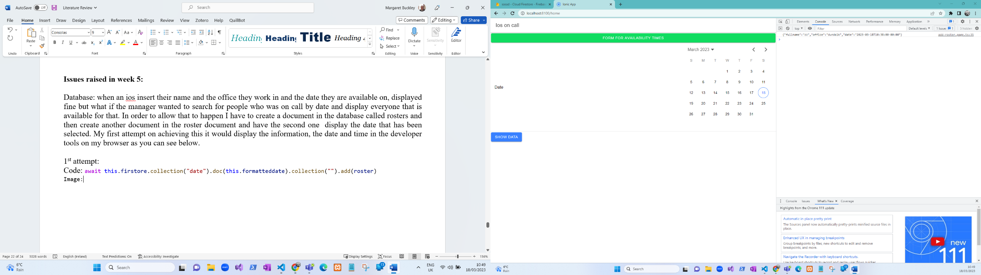

**Developer tools**

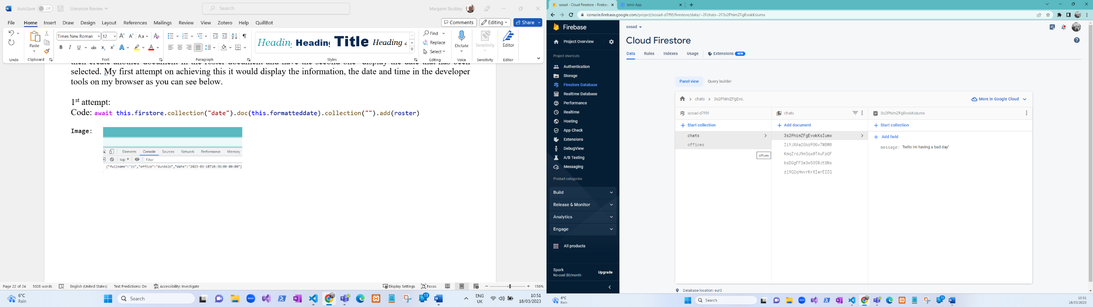**Database**

**What happens here?**

on the first attempt it doesn’t insert into the database, but it shows in the developer tools what you inserted in the form, and it is displaying the time you inserted the data.

**Attempt 2**

Code: await this.firstore.collection("rosters").doc(this.formatteddate).set({"key":this.firstore.collection("dates").add(roster)});

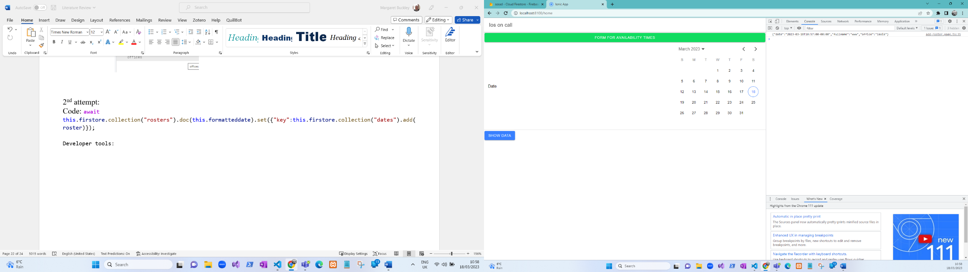

**Developer tools:**

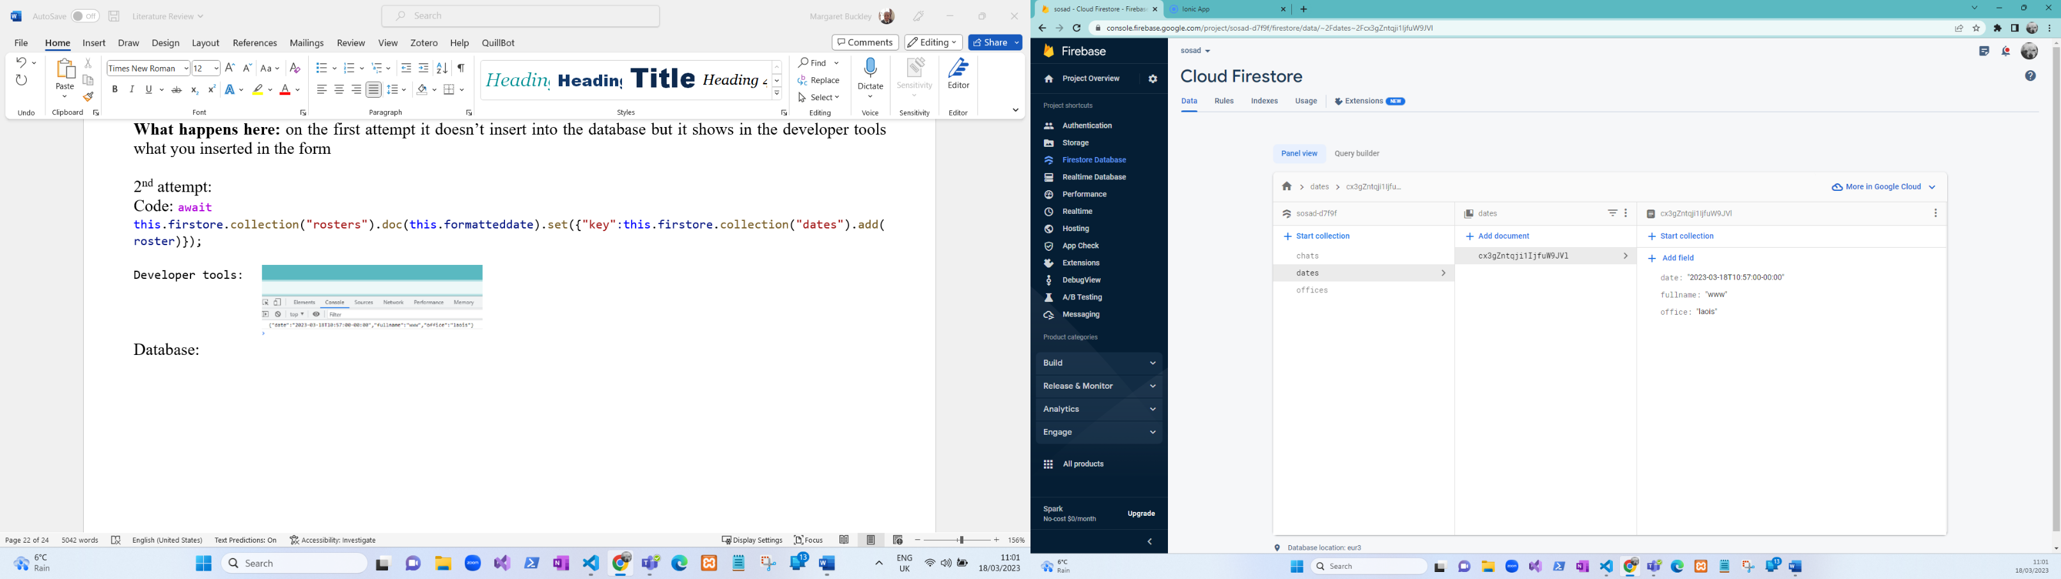**Database**

**What’s happening here** now the data is being inserted but it’s still displaying the time you inserted the data on, and it doesn’t create a document in a document.

**Attempt 3**

**Code:** await this.firstore.collection("roster").doc(this.formatteddate).collection("rosters").add(roster)

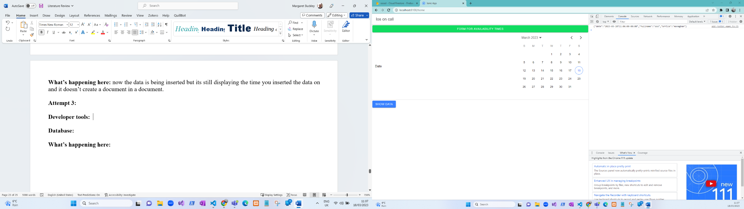

**Developer tools**

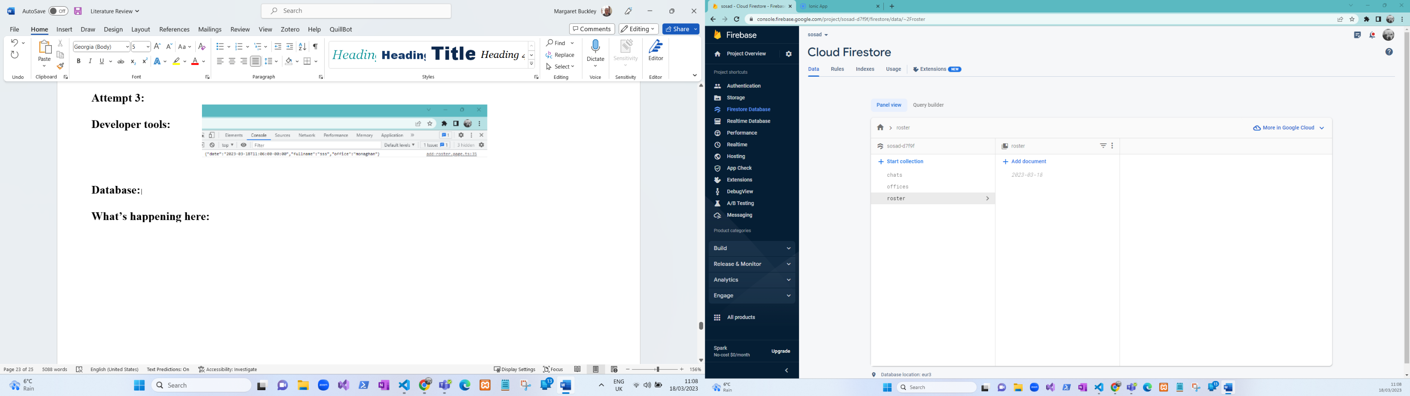

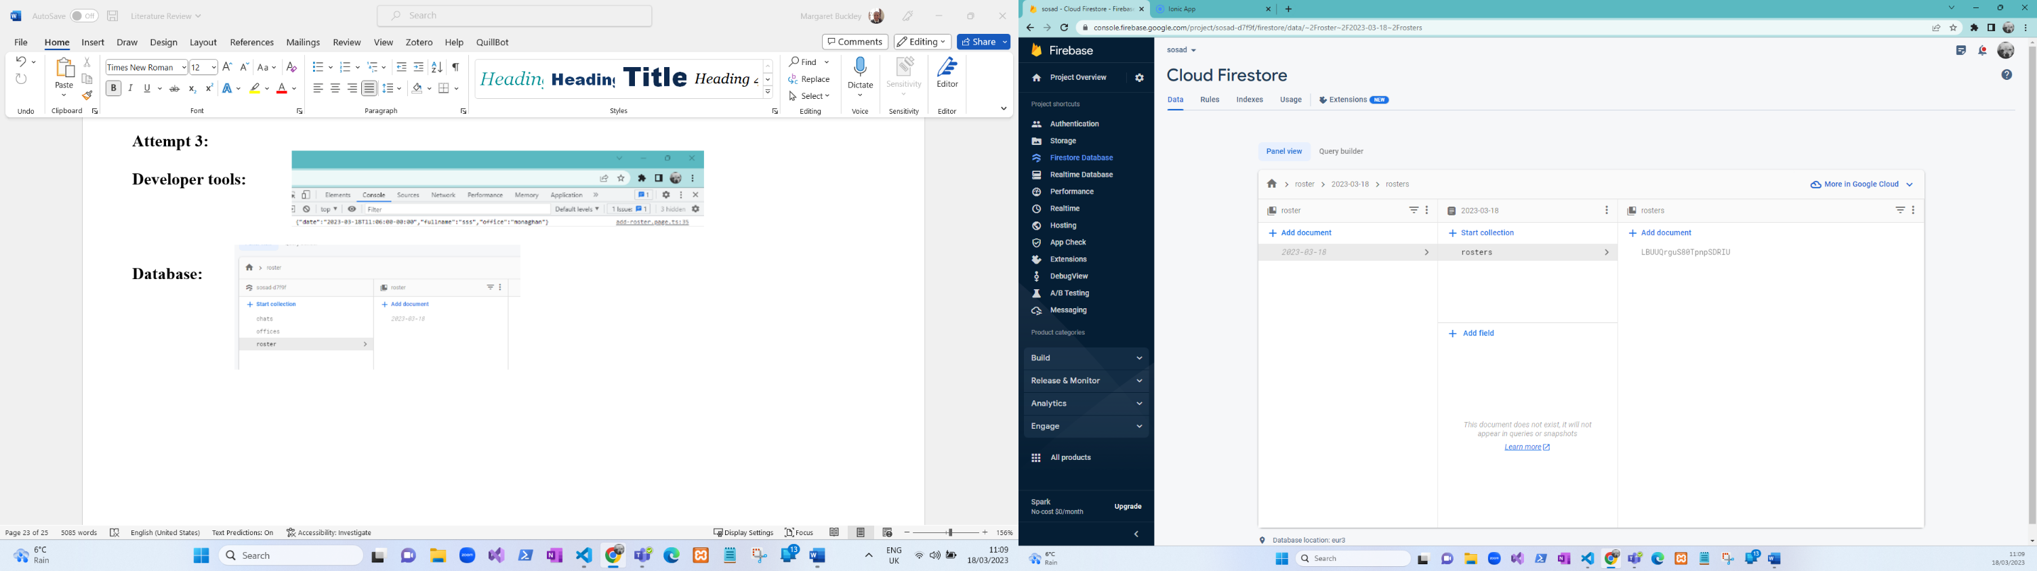

**Database**

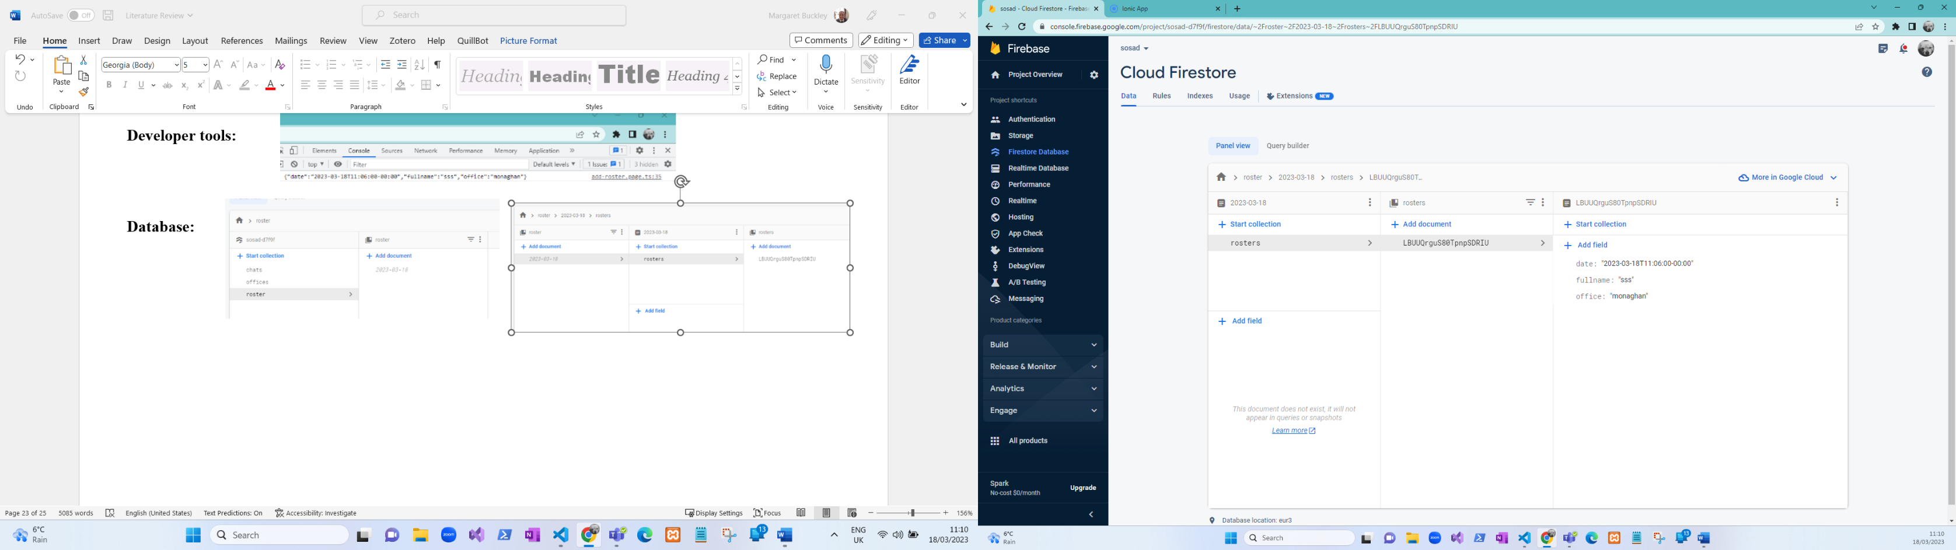

What happens here: so now when the Ios insert their data into the database it is stored in a document called roster then the second document is called by the date that has been selected and in the second document it displays the Ios information.

**Fixed solution**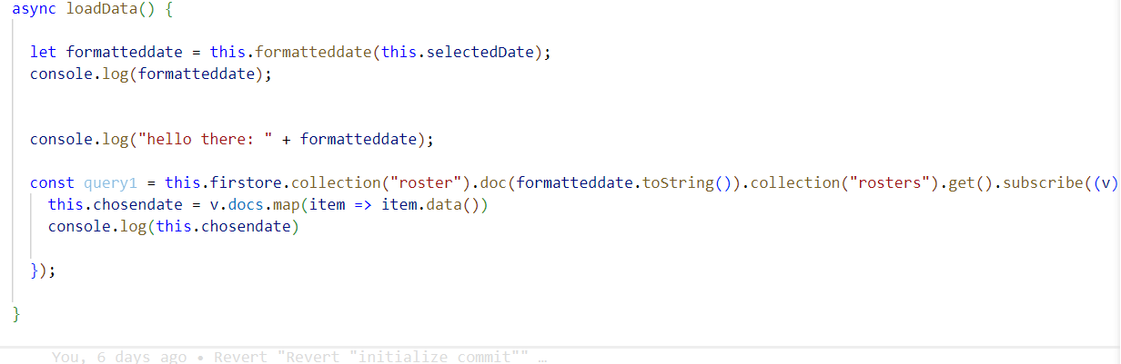

## **Week 6**

|  |  |  |
| --- | --- | --- |
| **Going to do** | **Tasks** | **Date Completed** |
| Chat | * Allow all staff and users to chat back and forth with each other. * Add the interface to the application | 31-03-2023 |

**Issues raised in week six**

the issue that I am having this week is when a date is selected it won’t display the data.

Attempt 1: let formatteddate = this.formatteddate(this.selectedDate)

 console.log(formatteddate);

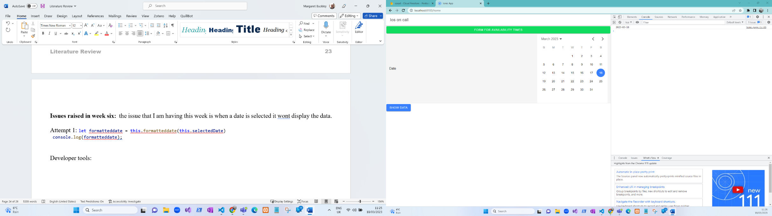Developer tools:

**What’s happening here**

is that it’s displaying the date but not the data inside of it.

Attempt 2:  const selectedDate = new Date(this.selectedDate);

    console.log(this.selectedDate);

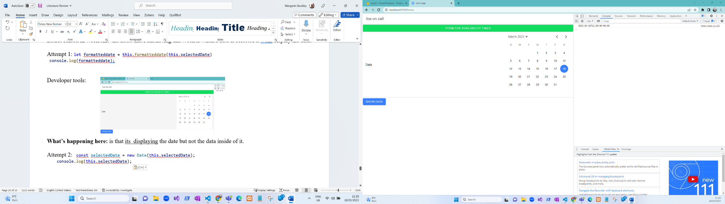**Developer tools**

**What’s happening here**

is that it’s displaying the date but not the data inside of it and now its displaying the time.

**Attempt 3**

  const query1 = await this.firstore.doc("roster/2023-03-18")//.collection('roster').get()

    console.log("query1 " +query1)

**Developer tools**

**What’s happening here?**

now it is returning an object but no data.

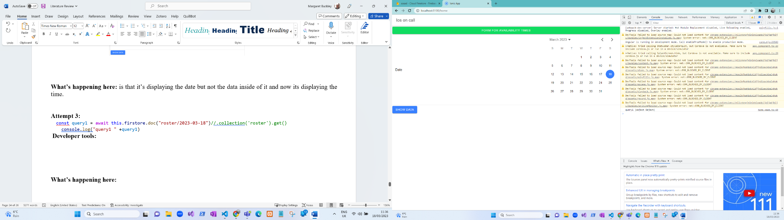

## **Week 7**

|  |  |  |
| --- | --- | --- |
| **Going to do** | **Tasks** | **Date Completed** |
| Google maps | * Allow users to select an office to find the location of the offices. * Add the interface | 26/04/2023 |
| Gherkin testing | * Add tests for the application | 15/04/04 |

**Issues raised in week seven.**

Ionic serve -l does not work when I try running the application, but the ionic serve works fine. Updating the application on my phone is now the only issue that I have. My laptop has died so now I am behind in my work as I am using a different computer to finish this off.

## **Week 8**

|  |  |  |
| --- | --- | --- |
| **Going to do** | **Tasks** | **Date Completed** |
| poster | * Adjust the poster. | 18/04/2023 |
| Android on phone | * Add add the application to the phone |  |
| Report | * Adjust the report |  |

**Issues raised in week eight.**

when adding a new feature to the application it broke the whole application and without thinking I had committed the broken application to GitHub. When I had realized that I had done that I had to retrieve an old commit before the application broke. This took some time to do but I have eventually got it back working. When trying to get the application onto my phone I have come across some issues, I am thinking that the issues is coming from the type of phone that I have.

## 

## **Week 9**

|  |  |  |
| --- | --- | --- |
| **Going to do** | **Tasks** | **Date Completed** |
| Motivational quotes | * Add quotes to the user menu. * Add the interface | 26/04/2023 |

**Week 10**

|  |  |  |
| --- | --- | --- |
| **Going to do** | **Tasks** | **Date Completed** |
| Get app on phone | * Add the application to the phone. | 07/05/2023 |
| Carry out usability testing | * Add the findings to the report. | 09/05/23 |

**Issued raise in week ten:**

When trying to get the application working on my phone it came to light that some of the dependencies were upgraded and somewhere not and there was a plugin that was out of date so that caused a lot of hassle and the ionic serve -l wouldn’t work because the version of ionic I was working on was ionic 7.1.1 so I had to downgrade the application. After some time, I managed to get back on track and got the application on my phone but then I had an issue with my xml file for android so after some research and playing around with the around with android studio. It finally updated and now the application now works on my phone. The only issue now is that there is a bug on the application preventing the google maps from loading but the google maps works perfectly fine on my laptop.

## **Useful links**

1. <https://imagecolorpicker.com/>: picking colours from images.
2. <https://ably.com/blog/realtime-chat-app-websockets-angular-firebase>: chat
3. <https://masteringionic.com/blog/working-with-capacitor-googlemaps-in-ionic>: google maps.
4. <https://github.com/D00196903/Sosad>: GitHub

# **References**

Contributor, T. (2022, November Tuesday). *Web application (Web app)*. Retrieved October 21st, 2022, from TechTarget : https://www.techtarget.com/searchsoftwarequality/definition/Web-application-Web-app

Cornell, J. (Last modified: May 31, 2022). *proprofs*. Retrieved March 10th, 2023, from https://www.proprofssurvey.com/blog/quantitative-research/

devs5003. (2022). *javatechonline*. Retrieved November 21st, 2022, from https://javatechonline.com/types-of-nosql-databases-and-examples/?utm_content=cmp-true

Fleetwood, D. (UN). *QuestionPro*. Retrieved March 10th, 2023, from https://www.questionpro.com/blog/quantitative-research/

Globaldots, A. (2018). *globaldots*. Retrieved February 18th, 2022, from https://www.globaldots.com/resources/blog/cloud-computing-benefits-7-key-advantages-for-your-business/

Iannce, K. (2021, october 31). *10 Best Hybrid App Examples*. Retrieved October 21st, 2022, from designli: https://designli.co/blog/5-best-hybrid-app-examples/

Itrobes. (2021). *Itrobes*. Retrieved October 21st, 2022, from https://www.itrobes.com/what-are-the-advantages-and-disadvantages-of-web-applications/

Ivy, K. T. (UN). *whatis*. Retrieved December Saturday, 2022, from https://www.techtarget.com/whatis/definition/mobile-app#:~:text=A%20mobile%20app%20(or%20mobile,than%20desktop%20or%20laptop%20computers.

Jackowski, M. (2020). *asper brothers*. Retrieved November 18th, 2022, from https://asperbrothers.com/blog/cross-platform-app-development/

Khan, U. (2018, july 12). *Clutch*. Retrieved October 21st, 2022, from clutch: https://clutch.co/app-developers/resources/pros-cons-native-apps

Lannace, K. K. (2021, October Sunday). *Designli*. Retrieved October 21st, 2022, from 10 Best Hybrid App Examples: https://designli.co/blog/5-best-hybrid-app-examples/

Microsft. (UN, November 10th). *What is cloud computing?* Retrieved October 21st, 2022, from azure Microsoft: https://azure.microsoft.com/en-in/resources/cloud-computing-dictionary/what-is-cloud-computing/

Pattinson, T. ( 2022, November 9th). *Relational vs. Non-Relational Databases*. Retrieved from Pluralsight: https://www.pluralsight.com/blog/software-development/relational-vs-non-relational-databases

Pattinson, T. (2022). *Pluralsight*. Retrieved October 23rd, 2022, from https://www.pluralsight.com/blog/software-development/relational-vs-non-relational-databases

TechMango. (2022). *TechMango*. Retrieved October 21st, 2022, from https://www.techmango.net/what-are-the-benefits-of-cross-platform-application-development

UN. (2021). *vervelogic*. Retrieved April Sunday, 2023, from https://www.vervelogic.com/blog/benefits-of-native-mobile-app-development/

UN. (2023, April Friday). *What Is Gherkin & How Do You Write Gherkin Tests?* Retrieved from TestQuality Blog: https://www.testquality.com/blog/tpost/dndmk5a141-what-is-gherkin-amp-how-do-you-write-ghe#:~:text=Gherkin%20is%20a%20programming%20language,adheres%20to%20a%20strict%20syntax.

UN. (Last updated: Apr 4, 2023 1:59 PM). *USCLibraries*. Retrieved April 10th, 2023, from https://libguides.usc.edu/writingguide/quantitative#:~:text=Quantitative%20methods%20emphasize%20objective%20measurements,statistical%20data%20using%20computational%20techniques.

Un. (Un). *firebase*. Retrieved April 14th, 2023, from https://firebase.google.com/docs/database

Un. (Un). *Oracle*. Retrieved October Tuesday, 2022, from https://www.oracle.com/mysql/what-is-mysql/

UN. (UN). *software testing help*. Retrieved November 20th, 2022, from https://www.hostinger.com/tutorials/web-development-tools

unknown. (2022, November Friday). *Native Apps, Web Apps or Hybrid Apps? What’s the Difference?* Retrieved October 21st, 2022, from MobiLoud: https://www.mobiloud.com/blog/native-web-or-hybrid-apps

Williams, T. (June 14, 2021). *Grand Canyon University*. Retrieved April 11th, 2023, from https://www.gcu.edu/blog/doctoral-journey/why-quantitative-research-important#:~:text=The%20purpose%20of%20quantitative%20research,or%20events%20that%20affect%20people.&text=Quantitative%20research%20produces%20objective%20data,communicated%20through%20st